Third Peak Manual

Release 2.0

Publication

Hopefully soon

Written By Thomas Müller

AG Engstler

Cell- and Developmental Biology I

University of Würzburg

Germany

Table of Content

1. General Information 4

1.1 Introduction 4

1.2 License 4

1.3 Requirements 4

1.4 Installation 5

1.5 Running the software 5

1.6 Inspiration 6

1.7 External Functions 6

2 The interface 7

2.1 Startup-Window 7

2.2 Preprocessing 7

2.2.1 Overview 7

2.2.2 Load Data 9

2.2.3 Data Filter 10

2.2.4 Drift Correction 11

2.2.5 Automated tracking using swift 12

2.2.6 Setting the save location and processing the data 12

2.2.7 Parameter Estimation 13

2.3 Validation 14

2.3.1 Overview 14

2.3.2 Import Settings 14

2.3.3 Navigating the data 15

2.3.4 Adjusting Offsets 16

2.3.5 Track overview 17

2.3.6 Image stack data 17

2.4 Visualization 18

2.4.1 Overview 18

2.4.2 Import Tracks 19

2.4.3 Image Settings 19

2.4.4 Dimensions and Plot 20

2.4.5 Karyogram 21

2.4.6 Single Track Analysis 21

2.4.7 ROI selection 22

2.4.8 Supermap and cluster generation 23

2.4.9 Complete Analysis 26

2.5 All Track Analysis 26

2.5.1 Overview 26

2.5.2 Histograms 27

2.5.3 Statistics 28

2.5.6 Data Filter 31

2.5.7 Data Export 32

# General Information

## Introduction

Third Peak is a MATLAB-based tool designed to facilitate the visualization and analysis of both 2D and 3D single particle tracks, particularly focusing on biological data. While the exploration of single molecule dynamics has been a subject of study for numerous years, most of the research has been confined to two-dimensional contexts. Nevertheless, it is important to recognize that even though microorganisms and cells are small, they exist within a three-dimensional regime.

Despite the availability of tools like Picasso or SMAP for localizing signal emitters, and the ongoing development of tracking algorithms to enhance our comprehension of molecule dynamics, there has been a noticeable absence of a free, user-friendly solution for visualizing accumulated data and interpreting it within a biological framework, all without necessitating extensive coding skills. Thus, I have developed Third Peak, a software application intended to preprocess, validate, and visually represent (three-dimensional) track data. This tool streamlines the analysis of 3D single particle tracks in a biological context.

## 1.2 License

This program is free software. You can redistribute and/or modify it under the terms of the GNU General Public License as published by the Free Software Foundation, either version 3 of the license, or (at your option) any later version. This program is distributed in the hope that it will be useful, but WITHOUT ANY WARRANTY, without even the implied warranty of merchantability or fitness for a particular purpose. See the GNU General Public License for more details. You should have received a copy of the Genus General Public License along with this program. If not, see. [*http://www..gnu.org/licenses/*](http://www..gnu.org/licenses/)*.*

## Requirements

For single molecule tracking

* Single molecule data
* Localization software
  + Picasso
  + SMAP
* Tracking software
  + Swift
  + Tardis
  + NOBIAS
  + U-Track 3D

For the use of Third Peak

* Matlab 2023a if using the Github repository.
* Matlab Runtime 2023a.
* Windows 10 or above if using the compiled program.

Optional for DeepSPT

* Python 3.8
* DeepSPT package

## 1.4 Installation

The files for Third Peak can be found here:

<https://github.com/unithmueller/ThirdPeak>

For Windows:

* Install the Matlab Runtime 2023a

<https://de.mathworks.com/products/compiler/matlab-runtime.html>

* Install Third Peak by the latest .exe from the releases tab

For Mac:

* Install the Matlab Runtime 2023a

<https://de.mathworks.com/products/compiler/matlab-runtime.html>

* Install ThirdPeak

Directly from Matlab:

* Open Matlab, go to the APPS tab and select “Install App”
* Select the ThirdPeak.mlappinstall

or

* Select the Third Peak directory cloned or downloaded from Github
* Add the Path and Subfolders to the Matlab environment
* Navigate to the GUI folder and open SelectionWindow.mlapp

For DeepSPT

I would recommend using anaconda/conda as a python runtime environment management software. DeepSPT requires Python 3.8 due to some package dependencies, but this could break current python environments. After setting up the environment for python 3.8, install the dependencies for DeepSPT.

In the AdditionalScripts folder is a DeepSPT folder that contains several text files that needs to be edited to fit the local environment.

* PythonDeepSPTEnvironmentPath contains the path to the python executable which is part of the DeepSPT environment in anaconda/conda
* DeepSPTLocationPath contains the path to the cloned Repository
* hMM_used contains the path to the fingerprinting model that should be used
* mode contains the mode selection for python; 0 represents the standard analysis and is currently the only implemented option
* Downstream_LSM_used can contain a path to a custom model to determine diffusion type changepoints as shown in the associated publication of the Hatzakis lab
* Dowstream_MLP-used can contain a path to a custom model to determine differently diffusing particles as shown in the associated publication of the Hatzakis lab

## 1.5 Running the software

For Windows:

* Start the software using the .exe in the installation or folder or the icon on your desktop

For Mac:

* Open the terminal
* Move to the directory where ThirdPeak is located inside the terminal
* Type “/run_ThirdPeak.sh<MatlabRuntimeDirectory>”.

Directly from Matlab:

* After opening the SelectionWindow.mlapp, press start in the AppDesinger window

Or

* Got to the APPS tab and select Third Peak from the available apps

## 1.6 Inspiration

This software draws inspiration and integrates numerous functions from various available software tools. One prominent mention is the "TrackIt," which consistently emerges as a cornerstone for processing single particle data seamlessly from start to finish. Several of its functions have been incorporated into this software tool (https://www.nature.com/articles/s41598-021-88802-7).

Another noteworthy software is "SPTAnalyser," which collaborates with the Swift algorithm to deduce relevant tracking parameters. (https://www.frontiersin.org/articles/10.3389/fcomp.2021.757653/full).

Furthermore, the "SPT Analysis" by Pierre Parutto has also been influential, inspiring the inclusion of heatmaps and additional features. However, the challenge arises when dealing with 3D data availability, making this approach considerably more intricate. ( https://www.sciencedirect.com/science/article/pii/S2667237522001540?via%3Dihub) .

I further integrated DeepSPT into the software as biological data is often showing confined diffusion and with this neural network tool I anticipate that it will be easier to understand and interpret biological processes. (https://www.biorxiv.org/content/10.1101/2023.11.16.567393v1)

## 1.7 External Functions

This software uses additional functions from the following repositories:

* MSDAnalyzer: <https://github.com/tinevez/msdanalyzer/tree/master>
* TIFFStack: <https://de.mathworks.com/matlabcentral/fileexchange/32025-dylanmuir-tiffstack>
* Mean-Shift-Drift-Correction: <https://github.com/frankfazekas/Mean-Shift-Drift-Correction>
* Peak finding and measurement: <https://de.mathworks.com/matlabcentral/fileexchange/11755-peak-finding-and-measurement-2019?s_tid=srchtitle>
* TrackIt: <https://gitlab.com/GebhardtLab/TrackIt>
* JDD_Code: <https://github.com/rmenssen/JDD_Code>
* HDBSCAN <https://github.com/Jorsorokin/HDBSCAN/tree/master>

# The interface

## Startup-Window

The initial interface of the software presents the user with the option to select from the three primary components. The initial component involves preprocessing, where users can ready their data for subsequent tracking, utilizing either the Swift algorithm or an alternative algorithm of their preference. Subsequently, within the validation phase, users can superimpose the newly tracked data onto their original microscopy image. This step enables them to identify any potential tracking errors or ascertain whether any enhancements are necessary before proceeding with analysis. Finally, within the visualization interface, users have the capability to examine the tracked files, refine track subsets as needed, and conduct analyses on the specific properties within those tracks.

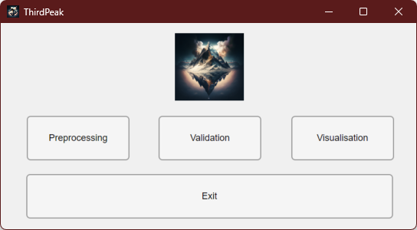

Figure 1: Starting window of ThirdPeak that allows to select the feature of choice. Either start with the preprocessing of the data, validate the tracking results or visualize and analyze the tracking results further.

## Preprocessing

Within the preprocessing phase, users can sift through the localization data extracted from their original single molecule images. This sifting is based on precision and position, and the filtered data is stored in a compatible format for utilization with the Swift tracking algorithm. Throughout this procedure, specific statistical values are computed, which serve as essential input parameters for Swift or any alternative tracking algorithms. Subsequent to the tracking process, users can derive supplementary parameters from the tracked files, thereby enhancing the precision of the tracking process. Users might opt out during each stage in the preprocessing and continue with other algorithms, as the data can easily be saved as a CSV file.

### 2.2.1 Overview

The preprocessing workflow works from the top to the bottom of the graphical user interface (GUI). The whole process can be subdivided into three required parts and two optional parts.

1. The user will have to choose between the localization data or imaging data in the first step.
2. Set the data type settings if processing localization data.
3. Select the file locations of the files.
4. Optional: Define the filtering parameters.
5. Optional: Perform drift correction with or without reference.
6. Set the save location of the processed data.
7. Start the processing.
8. Optional: Load tracked data to determine further tracking parameters.
9. Optional: Determine the overall resolution of the data using Fourier Shell or Fourier Ring Correlation.

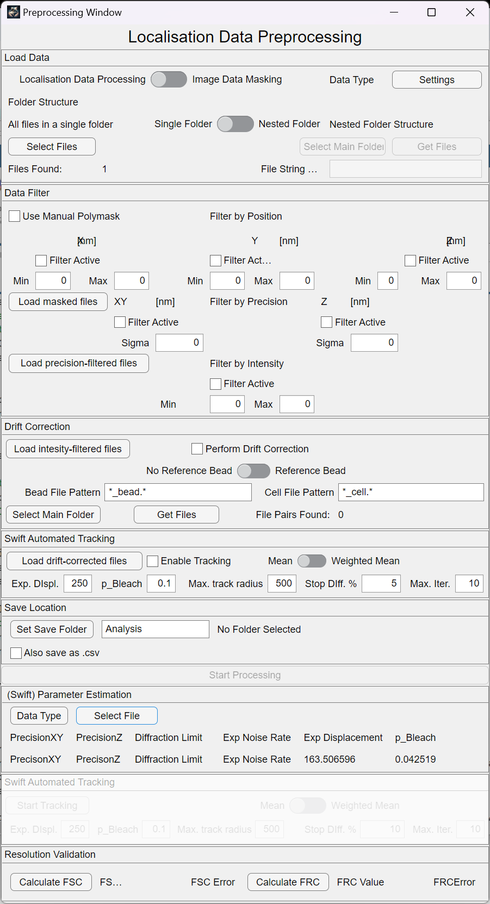

Data type and file selection

Optional:

Localisation data filter

Optional:

Drift correction

Optional:

Tracking using swift

Save Location of processed data

Tracking parameter estimation

Optional:

Tracking without preprocessing

Optional:

Resolution determination

Figure 2: Preprocessing window immediately after opening. Most of the components are deactivated to guide the user through the necessary data.

After starting the Preprocessing step, most of the GUI will be disabled until the user makes the first choice in the “Load Data” panel.

### 2.2.2 Load Data

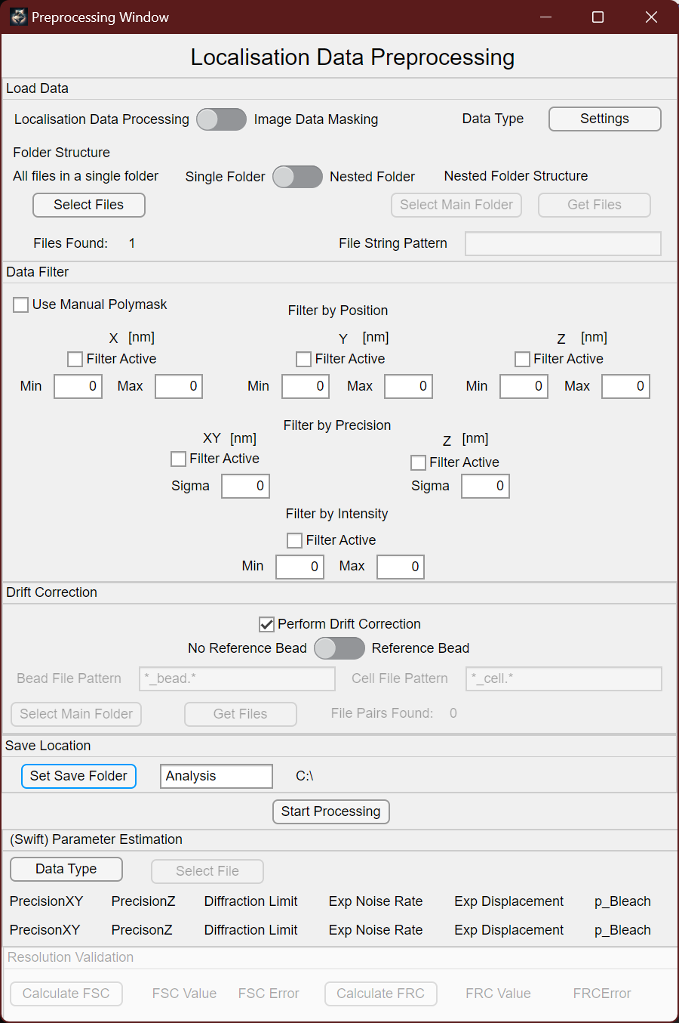

Figure 3: Panel to determine the data format and the location of the data that will be processed.

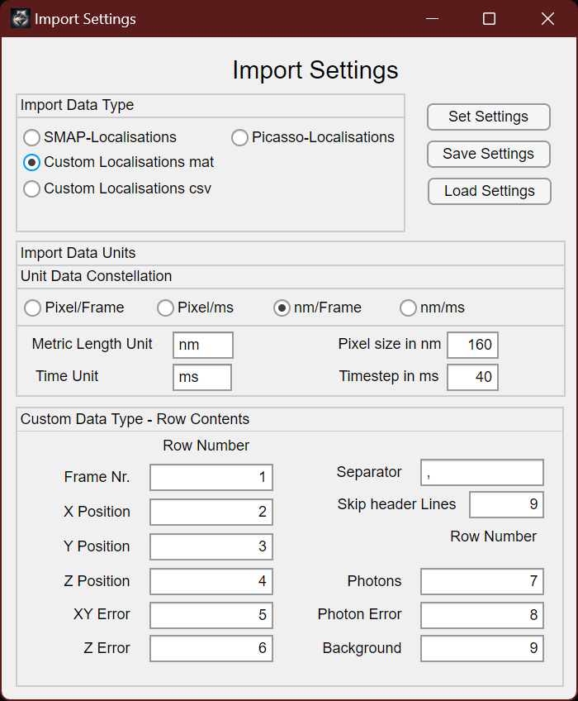First the user will have to decide if wants to process localization data or mask microscopy images. The localization data will then be further be processed for tracking approaches. Before processing the localization data, one needs to define the data type using the “Settings” button. This will open another window:

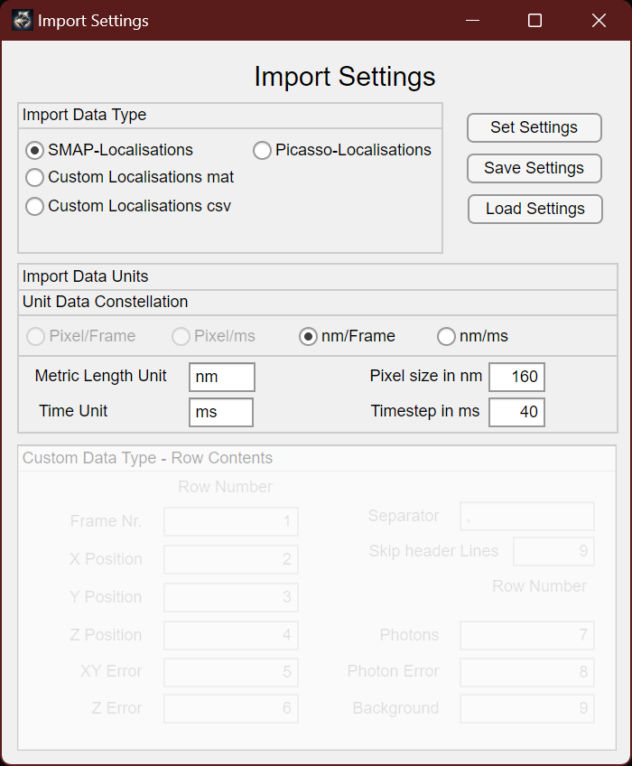First select the data type of your files, either being localizations from SMAP or Picasso. Alternatively, you can also load a custom “.mat” or “.csv” file. For this you will need to define in which column of the file the respective property of the data is stored.

Figure 4: Preprocessing settings window. This allows to determine the data type that will be loaded into the software.

Further you will need to determine which kind of unit constellation is present in your data. Choose between “Pixel/Frame”, “Pixel/Timeunit”, “Length/Frame” or “Length/Timeunit”.

If you have made manual adjustments to the import settings at the bottom, you might want to save them for later using the “Save Settings” button. You can retrieve them by using the “Load Settings” button.

Either way, once you decided that the settings are correct, press the “Set Settings” button confirm. This will then allow you to load your file data.

When loading the data, one has to choose between “Single Folder” or “Nested Folder”. For “Single Folder” you will select the files in a single folder that contains the localized data of your experiments. You will only be able to select the files with the correct file ending, defined during the settings dialogue.

When using the “Nested Folder” option, you will need to select a main root folder using “Select Main Folder” that contains all the folders you want to search in. Then define the “File String Pattern” that matches your file names, including the file extension (.mat, .csv). Use “%d” as a placeholder for the counting argument that might be included in the file (e.g. “Red_%d_MMStack.ome_sml.mat”).

In the end, press “Get Files” to search for the files. A counting element will tell you how many files have been found using the parameters given.

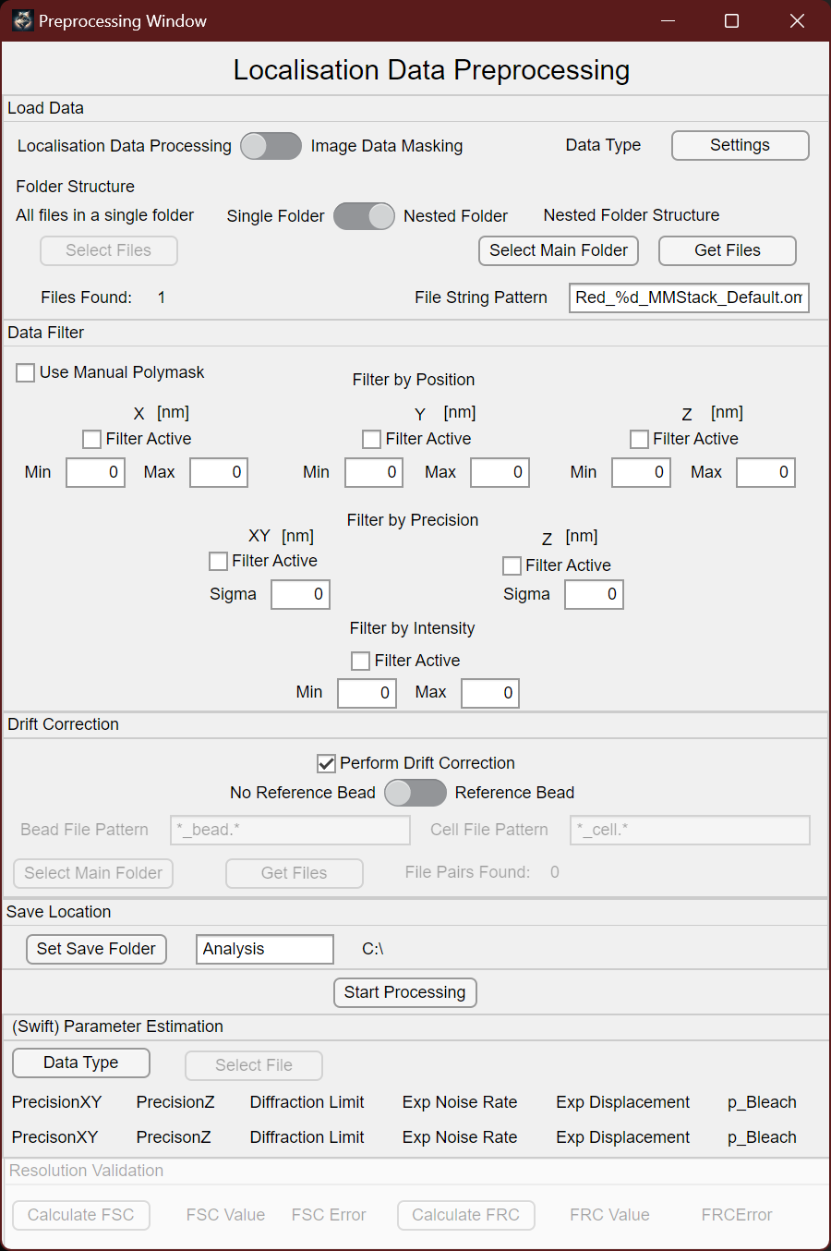

2

3

1

Figure 5: Using the Nested Folder option, first select the root folder that contains all the folders one wants to serach in. Then define the file name, using %d as a placeholder for the counting argument and the file extension. In the end press "Get Files" to search for them. The „Files Found“ will tell how many files will be processed.

Microscopy images can be masked to split them into a fiducial, or reference points (usually fluorescent beads) and into the biological data (cell) image. When working on small scales (nanometers), the drift of the microscope stage (especially in Z) can heavy influence the data you acquire. To counter that, one method would be to computationally remove the known drift (from the beads) from the rest of the data. As fluorescent beads are usually very bright, they can interfere with the localization algorithm and prevent the detection of our actual single emitters. To overcome this problem, we simply remove the beads from the image and localize the beads and the emitters separately. The loading of the microscopy images works in accordance with the process described above. For the moment, only “.tif” files are supported.

### 2.2.3 Data Filter

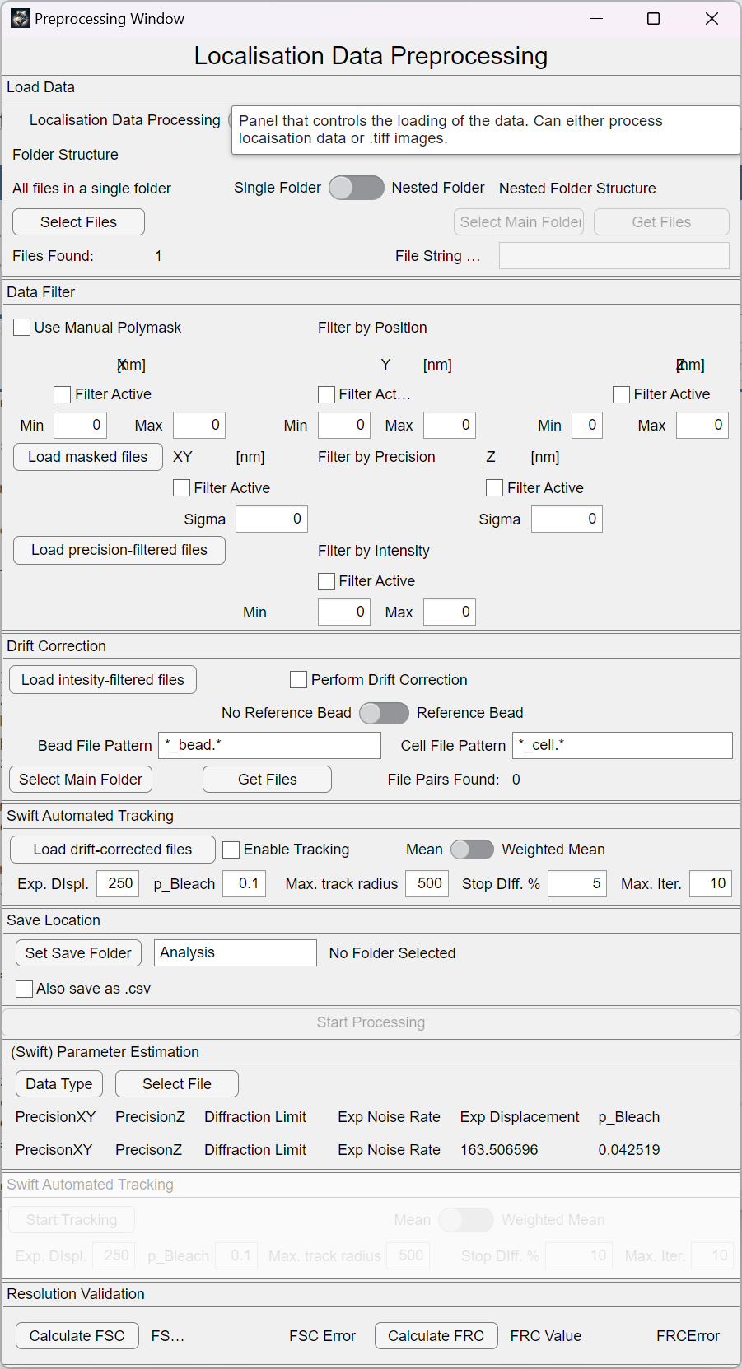

Figure 6: The data filter allows to filter localization data by the selected properties of their x,y or z position, their localization precision and their intensity.

The data filtering tool provides the capability to refine localization data through adjustments in coordinates, localization precision, or associated intensity values. Once a specific criterion is selected, the respective filter is automatically applied. To revert the filter, simply utilize the adjacent checkbox to deactivate it. Opting for the manual polymask entails the creation of a customized mask, accomplished by sketching onto the projected localizations within the X and Y plane of the localization data. To initiate the drawing process, press the spacebar, and individual points can be placed by utilizing the left mouse button. Upon completion of the mask, confirm by pressing the "Enter" button. Subsequently, the same file is reopened, beneficial in scenarios where multiple cells are present, enabling the masking process to be repeated. If no other cell is present, two presses of the "Enter" key conclude work on that file. Importantly, this manual polymask exclusively filters based on the X and Y values within the data.

The same process will also be true for the microscopy images. However, in this case the bead should be masked manually while the cell remains untouched. Also, each file will also will only be processed once. So once the mask is drawn and confirmed, there is no way back.

However, it is always possible to load already masked and/or precision filtered data from this workflow. As masking can be quite time consuming, this speeds up the preprocessing step if other parameters should be changed.

### 2.2.4 Drift Correction



Figure 7: The dirft correction can make use of the bead data generated during microscopy image masking to correct for drift present in the data. If no bead data is present, a mean-shift approach will be used.

The elective drift correction feature serves to eliminate any residual drift present in your tracking and localization data. This can be accomplished through a mean shift approach in cases without a reference bead, or by utilizing a reference signal like a fluorescent bead to rectify drift within the corresponding dataset. The bead data, crucial for this process, can be generated through the Image Data Masking process available in the beginning of the preprocessing window. Subsequently, the beads and the biological data can be independently localized. Each of these files can then be loaded during this stage if a reference is intended for use.

The loading procedure for these files adheres to the same principles as those in the Load Data panel. You would initially provide a main root folder for file searching, along with a file pattern designated for both the beat and cell data. Once more, the placeholder %d can be employed to account for the numerical count property within the file name.

Alternatively, a mean shift approach bins the data temporarily and tires to determine an overall direction of all localizations. If it can find one, it will correct for it.

A drift correction is also present in the visualization part of the software for convenience, however only the mean shift approach will be available and no reference can be used at this stage.

Alternatively, intensity-filtered files from a previous process can be loaded to skip the previous preprocessing steps.

### 2.2.5 Automated tracking using swift

This software can be used to automate the tracking process using swift. Usually, swift will only run one iteration per file and then it is up to the user to decide if the tracking results are plausible or not. Using the parameters determined below (Noise rate, expected displacement and bleaching probability), it is possible to determine new starting parameters for the swift algorithm, allowing it to converge closer to the dynamic process.

Initial starting parameters need to be given for the algorithm to function. It is possible to either use the overall mean of the expected displacement value, or the weighted mean, which additionally weights the frequency of the respective values.

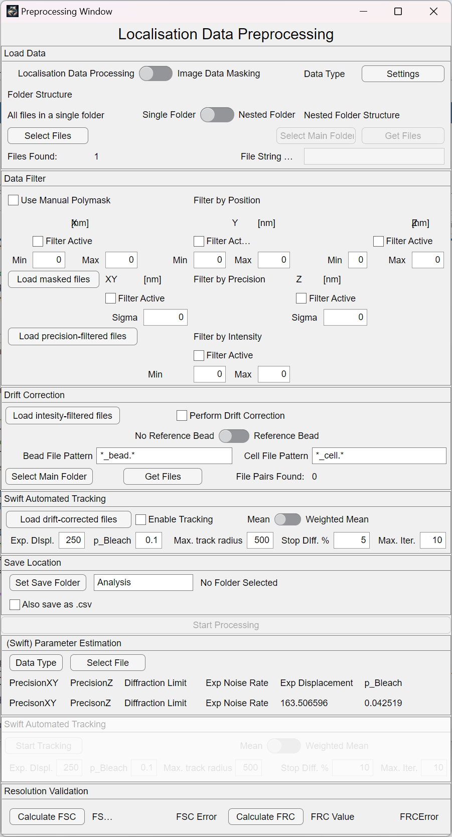

Figure 8: Automates the tracking using the swift algorithm by determining tracking parameters that can be used as new starting parameters.

### 2.2.6 Setting the save location and processing the data



Figure 9: Set the save location using the respective button. Only if all necessary inputs have been made, the "Processing" button will become available.

The final essential task is to configure the designated storage location. This action can be accomplished by clicking on the "Set Save Folder" button, which prompts the appearance of a folder selection dialog. Here, you can specify the folder where the analyzed data resulting from the analysis process will be stored. Each distinct analysis procedure will be saved within a separate folder, as determined by the content within the editing field adjacent to the button. If a folder name is already in use, a new folder will be automatically generated with a numerical enumeration appended, thus ensuring the safeguarding of analysis outcomes.

Located to the right of the safe location panel, the currently chosen storage location is displayed. If all the necessary information has been accurately provided, the "Start Processing" button should become accessible following the configuration of the safe location.

During processing, a file will be generated that contains all the configured settings, so one can look back at the values that have been used.

Using the “Also save as csv” button saves all processing steps as additional csv files if a users whishes to use a different software to proceed.

### 2.2.7 Parameter Estimation

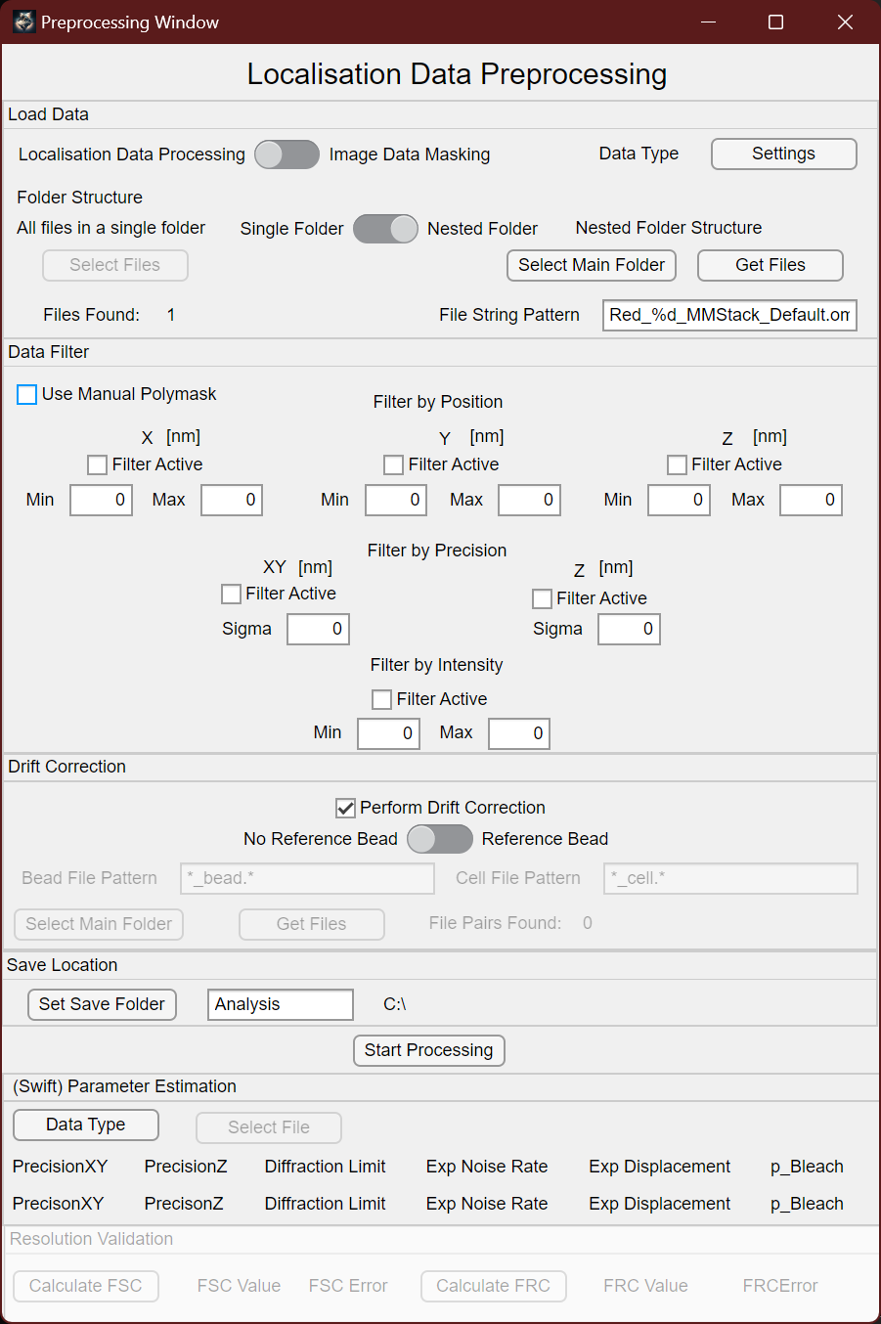

Figure 10: The parameter estimation shows key parameters usually necessary for the tracking process.

Upon completion of the preprocessing phase, the Parameter Estimation panel will exhibit the derived precision values for both the X and Y dimensions, alongside the established diffraction limit. These parameters hold critical significance for the subsequent tracking process, profoundly influencing the linkages forged by the algorithms. Additionally, the calculation of the diffraction limit takes place, particularly when dealing with sparsely populated datasets. This calculation involves determining the nearest separation distance within a given frame. In scenarios involving the use of a polymer mask, the noise is calculated by partitioning the residual background data from the data encompassed within the mask.

An alternative avenue involves opting for a specific data type, similar to the approach taken during the initial preprocessing stage. This option allows for the reopening and filtering of datasets, facilitating an assessment of tracking parameters. At this stage, single as well as multiple files are allowed. It is worth noting that previously tracked files from Swift can also be loaded to deduce pertinent information such as the impacted displacement and the probability of fluorophore bleaching. Adjustments to expected displacement and bleaching probability can be made based on these findings, leading to a subsequent iteration of the tracking process. The iterative refinement continues until the displacement and bleaching values reach a state of minimal change, indicating the convergence of the tracking process toward the most accurate values attainable from the available data.

Alternatively, an attempt can be made to ascertain resolution using methods like Fourier shell correlation or Fourier ring correlation. However, the efficacy of these techniques hinges on the volume of data accessible. It is crucial to acknowledge that carrying out these processes during the preprocessing stage may yield a more accurate diffraction limit calculation, while conducting resolution validation later in the analysis could potentially underestimate the true resolution present within the data. These approaches, nonetheless, offer enhanced robustness and contribute to an overall minute measurement of resolution across the entirety of the measured volume.

## 2.3 Validation

### 2.3.1 Overview

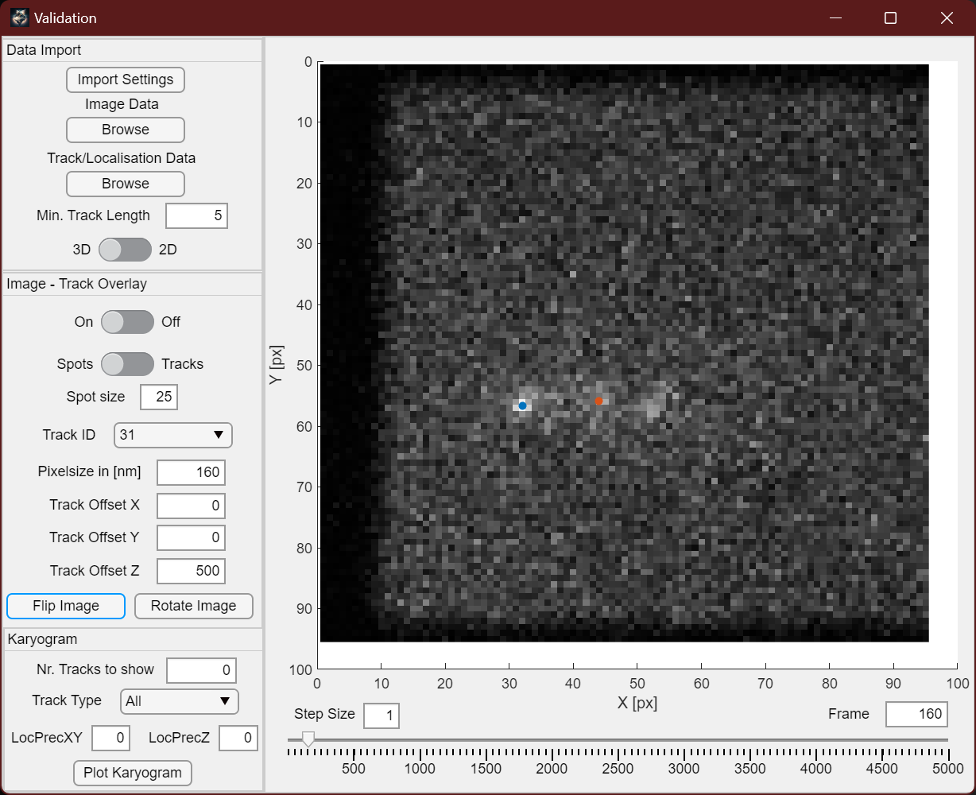The validation window enables you to inspect the microscopy image alongside the localization or tracking data obtained from it. Through this, you can assess the accuracy of the tracking and localization process. It empowers you to determine whether the process was successful or if any discrepancies exist in the localizations or connections.

Figure 11: Overview of the Validation window. This part of the software can be used to check if the localization and tracking has been successful or if further refinement should be done.

### 2.3.2 Import Settings

Much like the preprocessing window, the initial step involves accessing the Import Settings dialog to specify the anticipated data format for the software. This time around, the software provides the flexibility to import either localization data or track data directly from Swift, SMAP, or custom data formats.

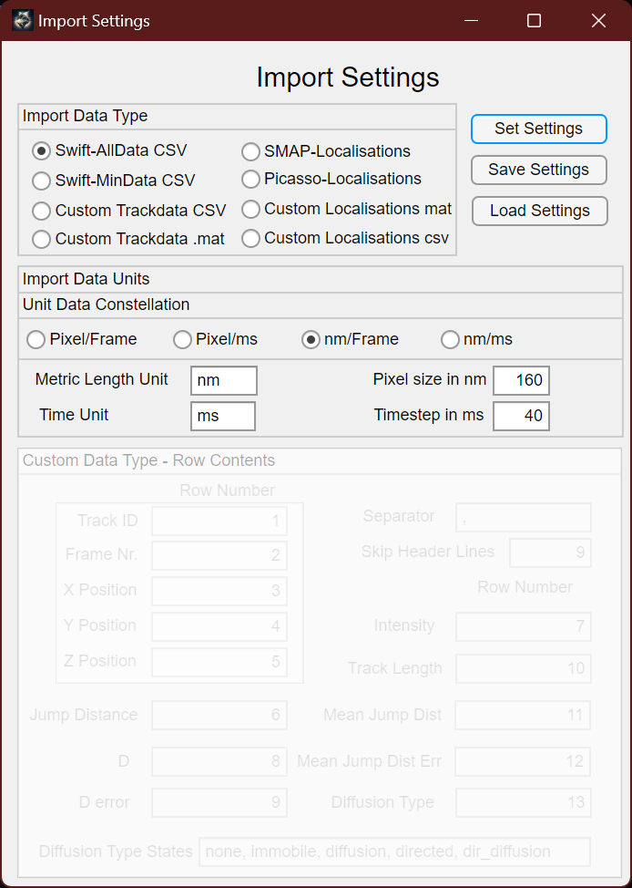

Figure 12: Extended import settings for the Validation step.

### 2.3.3 Navigating the data

Once the settings are confirmed using the set button, you can proceed by loading a microscopy image file. Adjacent to this, factual data is presented. On the left-hand side, you gain further control over determining the minimal track length for the loaded data. Tracks with step counts below this designated value will be filtered out, effectively eliminating sporadic localizations that may not be of interest. Beneath the minimal track length section, a switch enables you to choose between 3D or 2D plotting of your microscopy image data. Depending on your visualization needs, switching back and forth between these options might be necessary, particularly to activate the 3D visualization.

For 3D visualization, the figure panel's "Rotate 3D" function allows you to manipulate the displayed panel as needed.

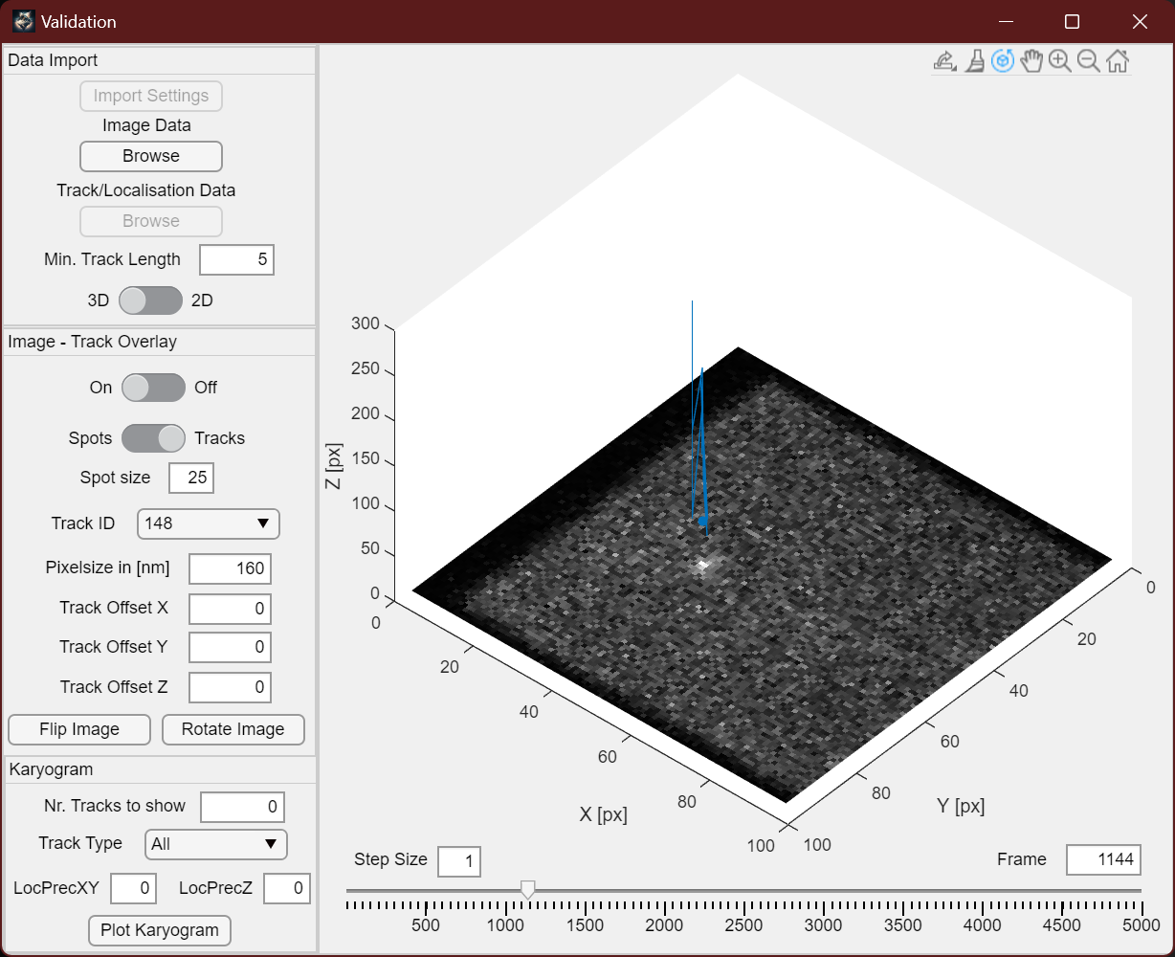

Figure 13: The Rotate 3D function of the figure is marked by a red box.

Within the Image-Track Overlay control panel, you can toggle the display of tracks on or off. If track data is selected, you can choose to plot just the spots (localizations) along the tracks or include the connections between tracks. The spot size field provides the capability to adjust the displayed size of the spots, enhancing visibility if necessary.

Utilizing the Track ID dropdown menu permits swift navigation to the specific time point where a track commenced.

### 2.3.4 Adjusting Offsets

The pixel size helps align the microscopy image with the tracked localizations, accounting for potential variations in units. If required, an offset can be introduced to the track data, accommodating instances where the microscopy image isn't a perfect fit or when additional 3D separation is desired.

The "Flip Image" and "Rotate Image" buttons offer the functionality to adjust the orientation of the microscopy image, useful in rectifying mirroring issues that may have arisen during localization, e.g. during SMAP.

Below the figure, the step size field lets you modify the time intervals for the time slider, facilitating rapid navigation through your track data's temporal progression using arrow keys. The frame number is indicated on the right side, and if you wish to jump to a specific frame, you can directly input its value there.

### 2.3.5 Track overview

The Karyogram panel provides a structured representation of all tracks present in the data file. If tracks are associated with specific diffusion types, filtering can be applied based on these types using the dropdown menu. Additionally, you can designate the localization precision in XY and Z for plotting as the first object in each row. This serves to establish a visual connection between the track's placement and the inherent data uncertainty. In typical cases, immobile tracks are defined by not exceeding their localization precision.

### 2.3.6 Image stack data

In the more recent version we included the support of image stack data. When choosing to load image data, one might select multiple, multilayer tif-files, that will be considered as a timeseries of volumetric image stacks. Upon loading this data type, a second scrollbar on the right appears that allows to change the z-plane in the data. The box below the slider determines the step size taken if using the up and down arrow keys to navigate.

Track data can be scaled using the Z Size parameter if localizations to not appear on the right plane. The image data might be flattened using the “Z-Max Intensity Projection” box.

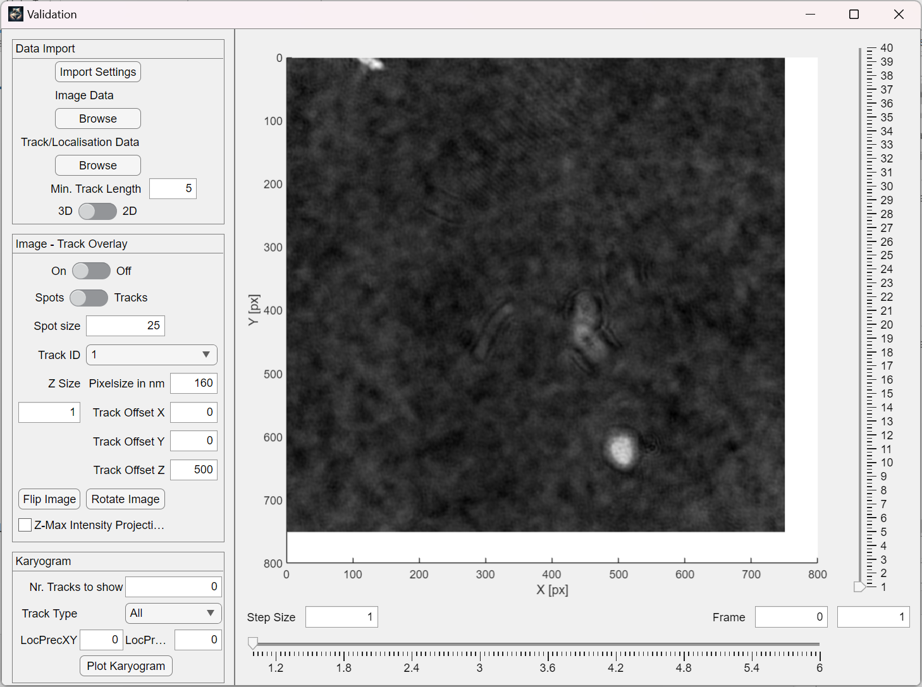

Figure 14: Validation window with volumetric image support.

## 2.4 Visualization

### 2.4.1 Overview

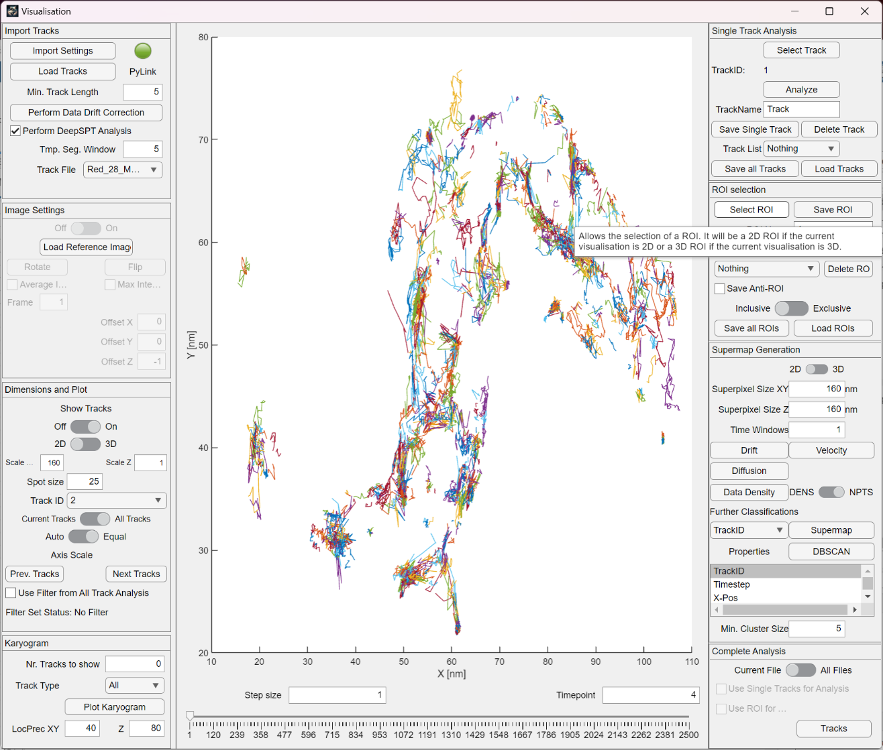

Figure 15: Overview of the visualization window. The left side controls data loading and visualization while the right hand side allows to subset the data and analyze it.

The visualization window permits the loading of data from multiple experiments, facilitating an overview of reconstructed tracks across various experiments. Furthermore, this part of the software allows for data subset selection, which can involve manual selection of individual tracks or choosing a specific region of interest. When dealing with limited data availability, an approach of reconstructing super maps is feasible by aggregating signal localizations into larger artificial pixels, thus enabling the computation of drift, velocity, or density within specific points of the data space. This tool provides the option to utilize either the complete dataset or the generated subsets to further analysis the tracks.

### 2.4.2 Import Tracks

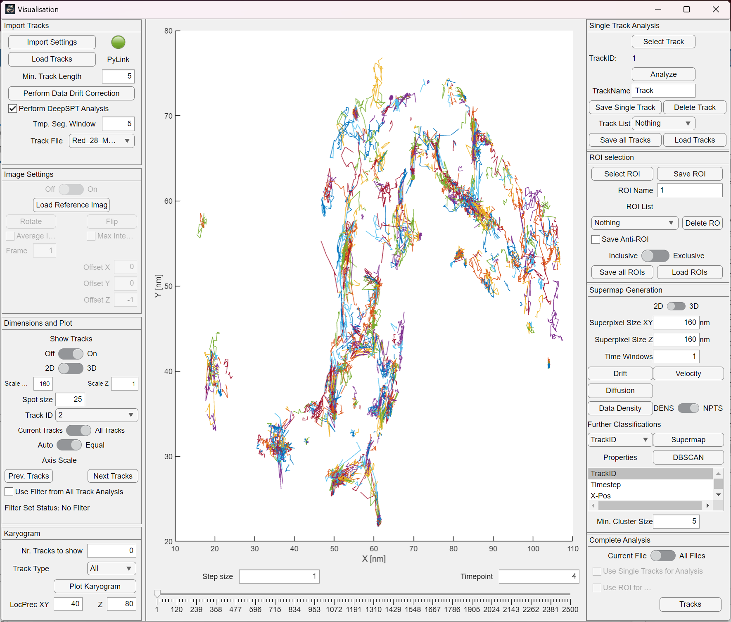

Figure 16: The import Tracks panels allows to set the respective settings, select the tracks, filter them by a minimal length and perform a drift correction. Further it enables the user to switch between different files. Optional processing using DeepSPT is also possible.

As with the preceding sections of the software, the initial step involves configuring the software's import settings, a prerequisite for processing the specific data type. Once these settings are confirmed using the settings button, the "Load Tracks" button becomes accessible. This function permits the loading of multiple files from a designated folder into the software. All loaded tracks undergo automatic filtering based on the value specified in the minimal track length field. This filtering process effectively eliminates any remaining unconnected localizations.

Furthermore, in a manner reminiscent of the preprocessing phase, the software now offers the capability to conduct data drift correction. However, this correction is solely achievable through the mean shift algorithm and not by utilizing a reference. The "Track File" dropdown menu empowers users to select the specific file to be showcased within the center of this window.

In the updated version, we integrated a connection to a python environment on the computer to enable the processing of tracking data using DeepSPT, a neural network based analysis framework for anomalous diffusion. The PyLink button will be green if matlab was able to find a suitable python environment which needs to be added to the files of ThirdPeak in a text file (see installation).

Selecting the checkbox “Perform DeepSPT Analysis” will send the loaded track data to DeepSPT for processing and will retrieve it once it is ready. As neural network processing is expensive, the generated data will also be saved in the same location as the loaded track data, thus speeding up the load time if the same data should be explored again.

### 2.4.3 Image Settings

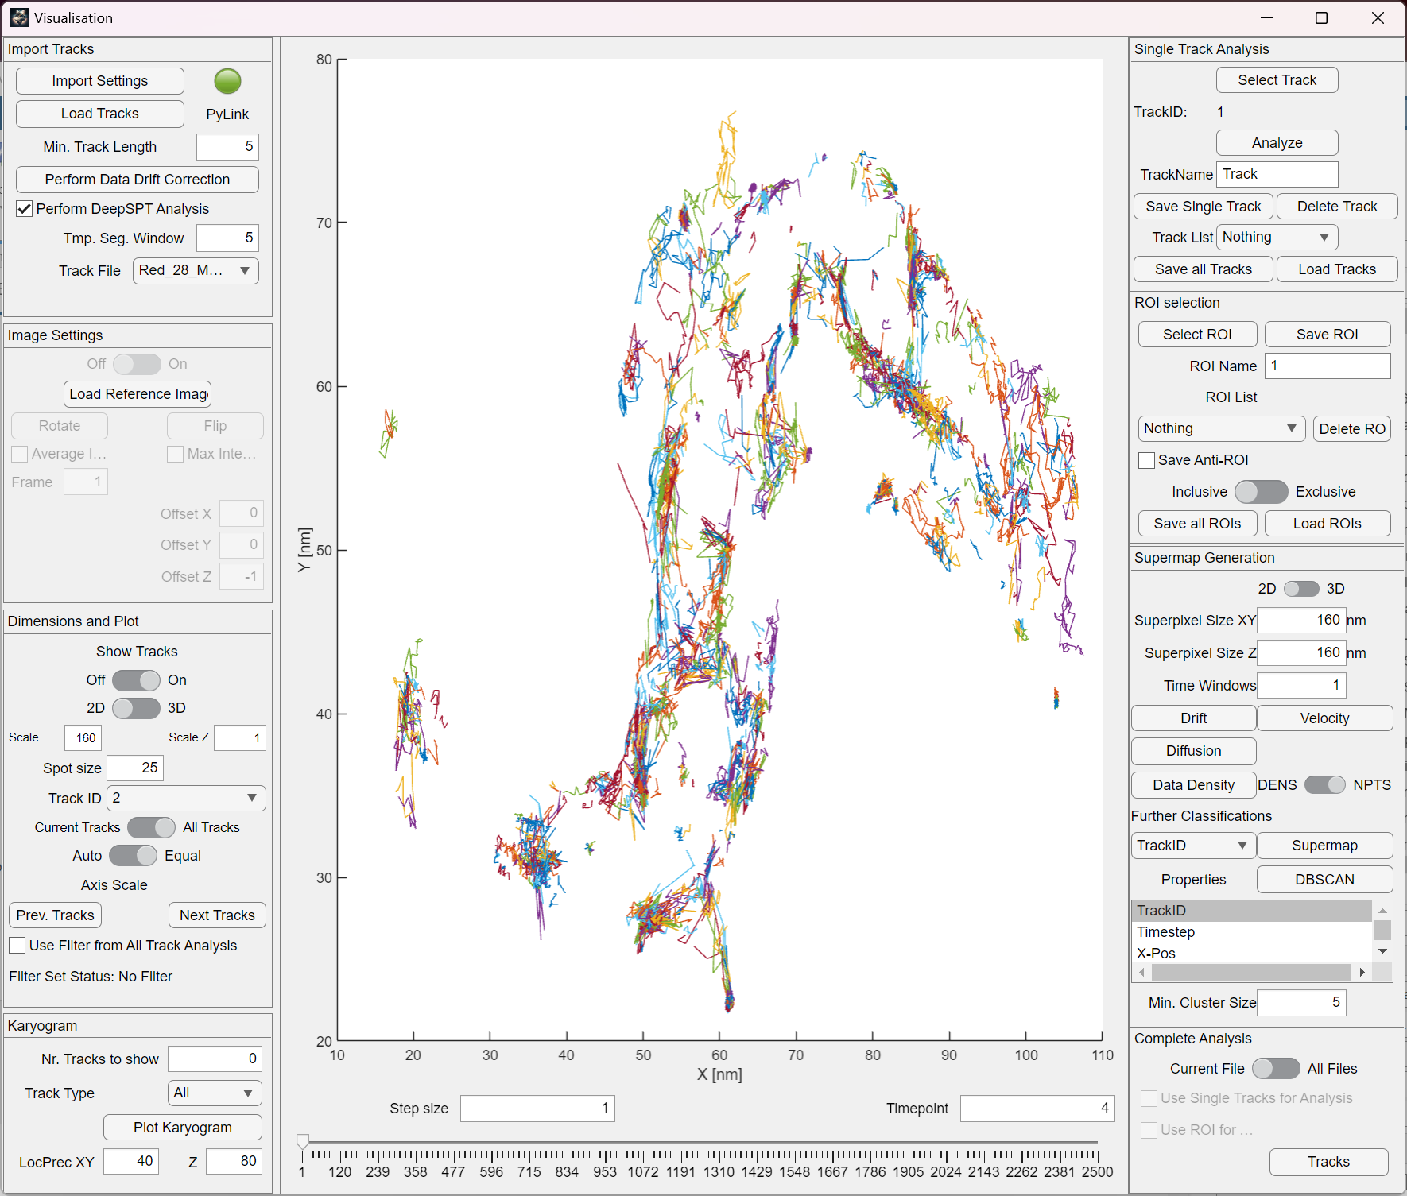

Figure 17: Allows to load a microsocopy image as a background. Again, we are able to rotate and flip it as needed and introduce an offset. Interactive scrolling using the arrow keys is not possible though. Volumetric data is also supported.

Alongside the tracks, it is possible to load and show a single reference image that serves as a background. This panel provides options for enabling or disabling the reference image, as well as for rotation or flipping as required. Rather than displaying a distinct frame from a time stack, an alternative option is to present the average intensity projection. This can be achieved by selecting the corresponding checkbox. Additionally, an image offset can be introduced if necessary.

In the updated version, a single plane of a volumetric image stack can also be visualized.

### 2.4.4 Dimensions and Plot

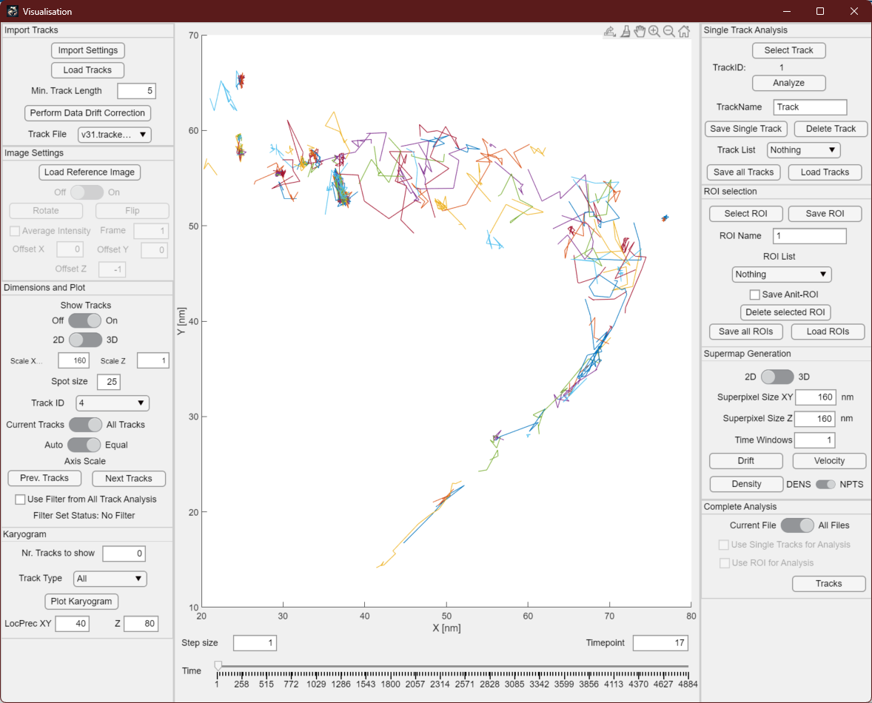

Figure 18: This panel controls how the tracks will be visualized in the middle of the window.

The dimensions and plotting panel offers various functions, including the option to display or conceal the tracks using the first switch. The second switch allows for toggling between a 2D and 3D representation of the tracks. Situated above the figure, a "Rotate 3D" button will be available to facilitate the rotation of tracks in a three-dimensional space when necessary. Adjusting the scaling factors for the X and Y axes enables data stretching or fitting to align the tracking data with the microscopy background image, if utilized. Additionally, the spot size parameter governs the size of plotted spot points, which can be enlarged for improved visibility.

Using the track ID dropdown menu, one can swiftly navigate to the start of a specific track by selecting its corresponding ID from the dropdown field. The subsequent switch enables control over whether all tracks should be displayed simultaneously or if they should be presented based on their temporal occurrence in relation to frame or time intervals. The final switch governs axis scaling, offering the choice between equal dimensions across all three axes or an auto-scaling option where dimensions may be adjusted with reference to the X and Y dimensions.

The "Previous Track" and "Next Track" buttons offer a convenient way to swiftly transition to the preceding or subsequent track ID and the corresponding time point. The "Use Filter" checkbox permits track filtering within the main window based on the predefined data filter established during track analysis. Further elaboration on this aspect will be provided subsequently.

### 2.4.5 Karyogram

The Karyogram panel provides a structured display of all available tracks in a systematic manner. They will either be plotted in 2D or 3D, depending on the settings in “Dimensions and Plot”. Through the selection of a specific track type, it becomes feasible to categorize the tracks based on their diffusion behavior, provided this classification is enabled by the external tracking algorithm. Additionally, the panel allows for the visualization of the localization precision of X, Y and. This information serves as a valuable reference, offering insights into the potential extent of the tracks' displacement.

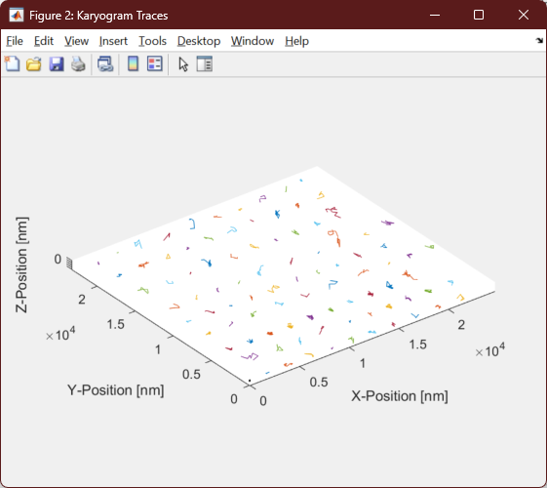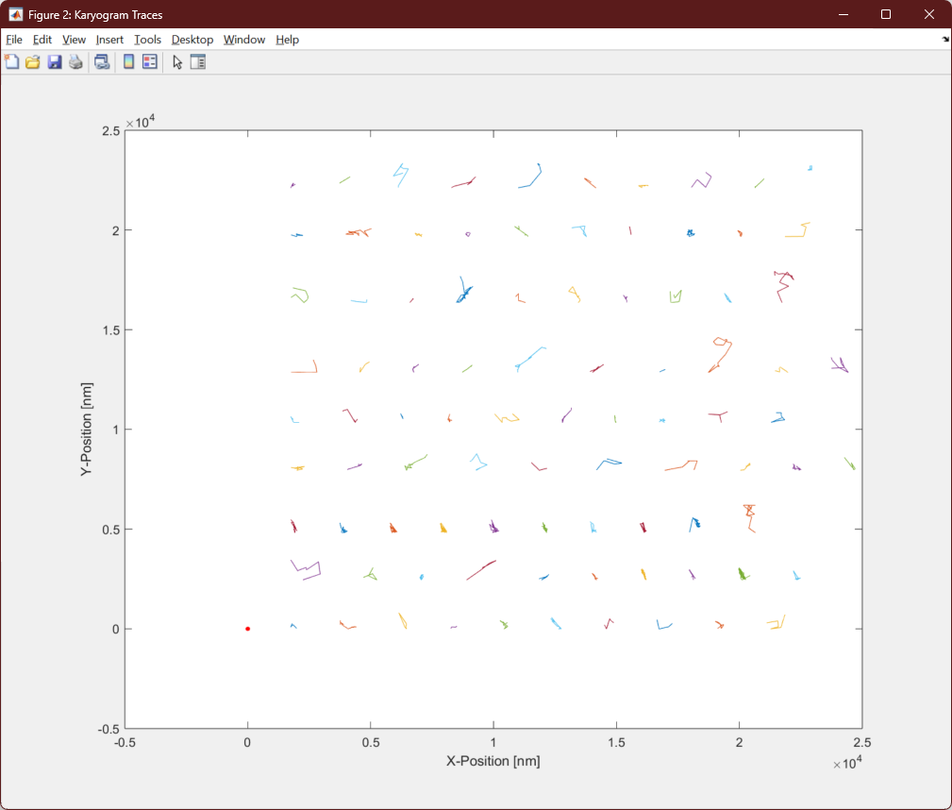

Figure 19: The karyogram allows to plot the tracks in an orderly fashion. Tracks will be either plot in 2D or 3D depending on the setting of the Dimension and Plot panel.

### 2.4.6 Single Track Analysis

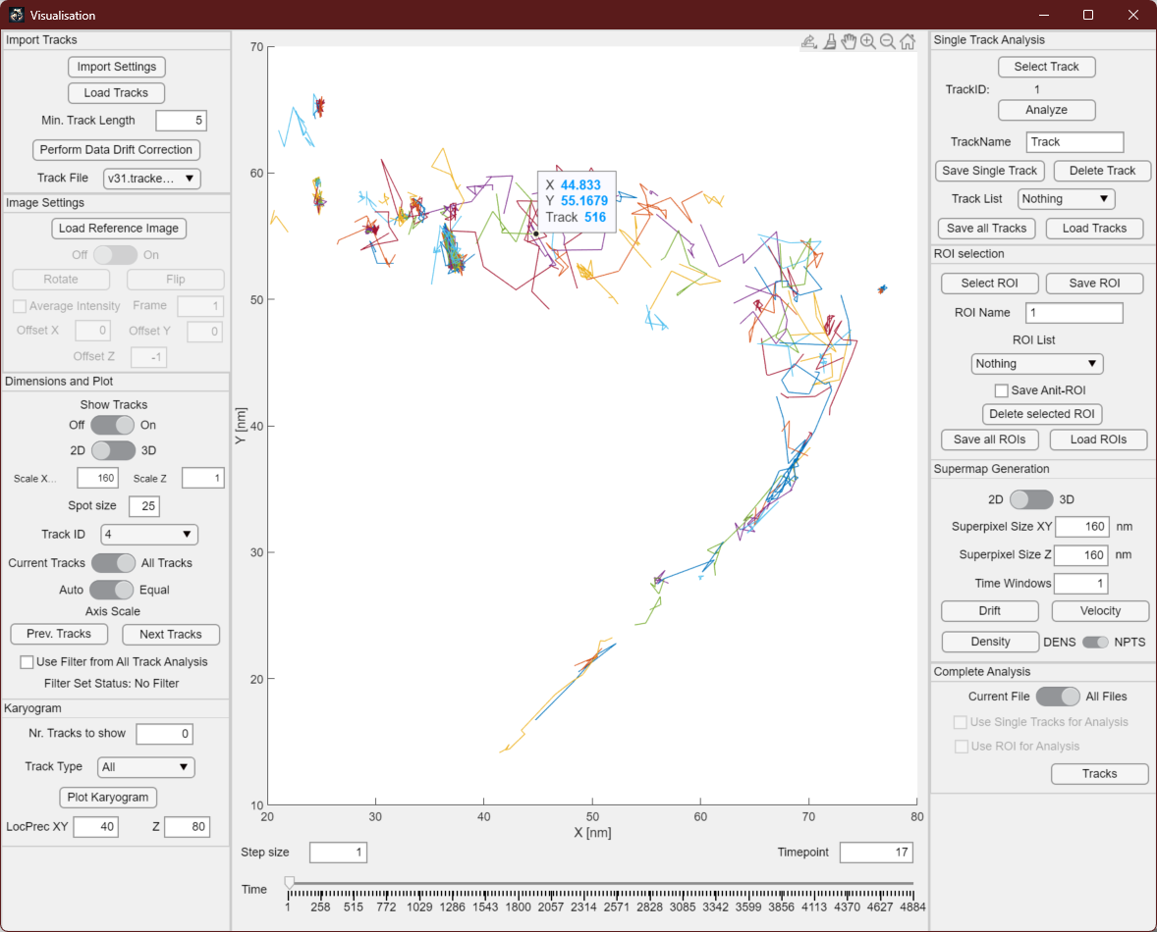

Figure 20: After clicking on "Select Track", the tooltip function of matlab will be activated and one can interactively click on a track in the main window. The track number will be displayed directly in the middle of the window, but also next to TrackID.

The single track analysis feature permits the selection of an individual track through interactive clicks within the main window. To initiate this process, the user must first activate the "Selected Track" button, prompting the cursor to transform into a tooltip mode. Subsequently, the user can pick a track from the collection displayed in the center. The track's unique ID is presented directly within the window and will also visible adjacent to the track ID in the single track analysis panel upon clicking the “Analyze” button. This function is currently only available when using 2D plotting of the data.

Upon clicking the "Analyze" button, a new window opens, presenting the user with track statistics. Furthermore, the option to save the chosen track for later analysis is available, allowing subsequent analysis on different selections of tracks. To facilitate this, a track name must first be assigned. If no distinct track name is provided and a name is already in use, an enumeration will be appended to distinguish it.

By selecting the "Save Single Track" button, the chosen track is saved, and its name is added to the track list dropdown menu below. To remove a track from this list, one can select it and use the "Delete Track" button. The tracks included in this list can be collectively saved using the "Save All Tracks" button and subsequently loaded via the "Load Tracks" button.

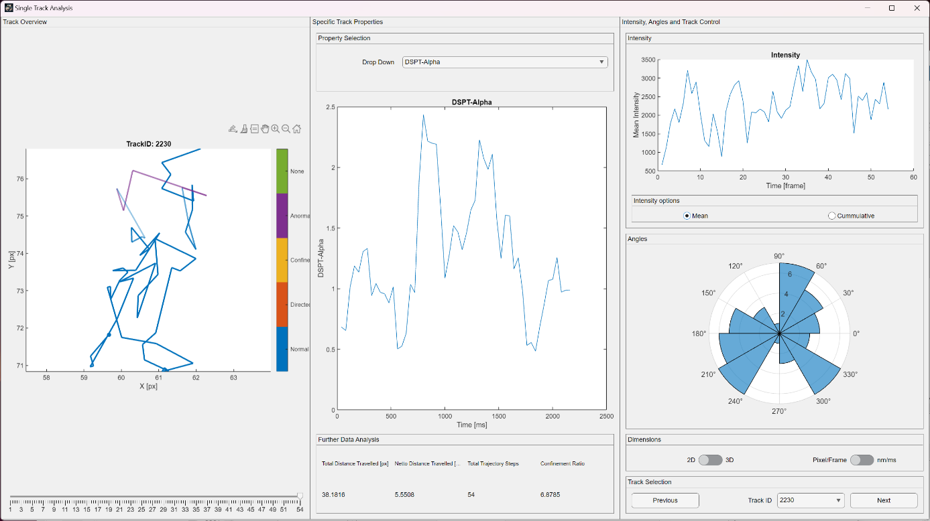

Figure 21: The single track analysis window will provide the statistics of the single track selected such as the jump distance, the intensity, the jump angles and it provides access to the calculated properties from within ThirdPeak, from external sources or DeepSPT.

The single track analysis module provides users with data concerning the track they have selected within the main window. Using DeepSPT enables to visualize the diffusion behavior of the single track on the left side, color-coding its diffusive state. The transparency of the color is an indicator for the probability of the state, with less opaque colors representing higher uncertainty.

In the center, several track statistics can be visualized, which differ on the amount of data available. Either from external sources, calculated by DeepSPT or after running the track analysis.

Furthermore, this analysis encompasses various parameters. It includes the overall distance covered by the track, as well as the net distance traversed, total trajectory steps, and the confinement ratio calculation. The confinement ratio is derived by dividing the net distance by the total distance.

Located at the bottom right, the interface offers navigation options such as "Previous" and "Next" buttons, alongside a dropdown menu enabling swift switching to different tracks and files.

### 2.4.7 ROI selection

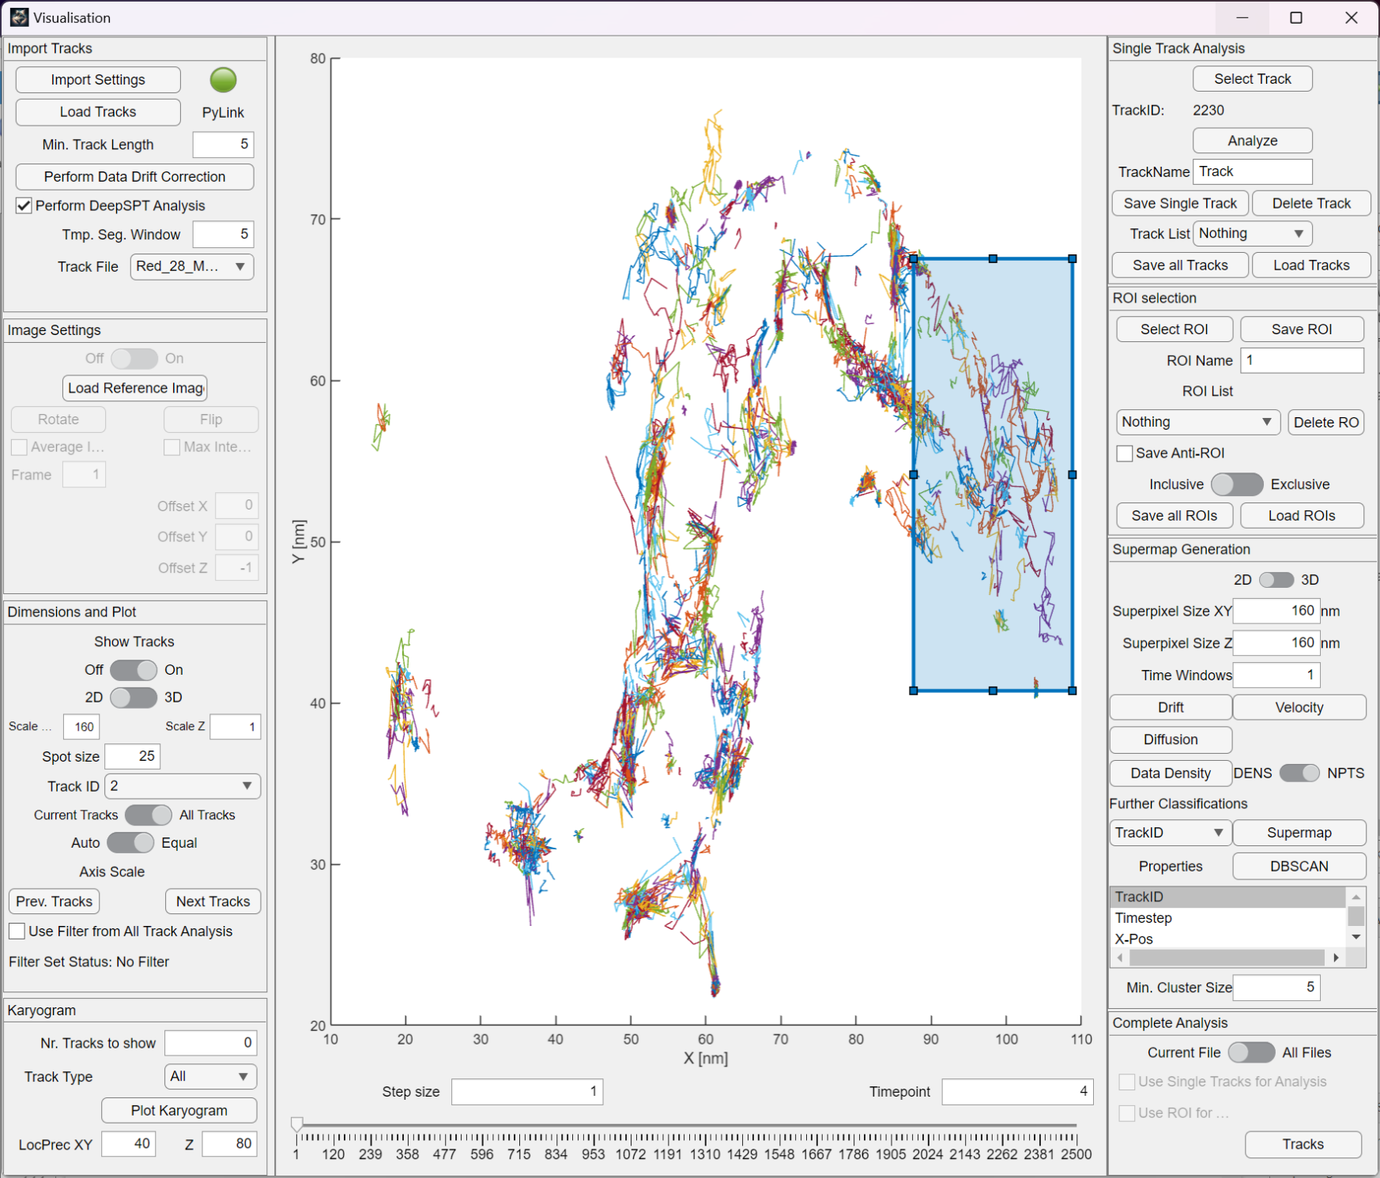

Figure 22: Interactive ROI selection for the data. Will enable to select a ROI in 2D or 3D and save if for analysis.

Similarly, yet not confined solely to a single track, this functionality extends to encompass our area of interest using the region selection panel. This tool permits interactive selection of a region of interest directly on the dataset. The representation can be either 2D or 3D, depending on the plotting configurations set within the software window's left-hand side.

Once the region of interest is situated on the dataset, saving the region involves pressing the "Save ROI" button. The saved region will adopt the designated name entered within the edit fields below the corresponding button. The saved regions are accessible within the "Region List" dropdown menu, denoting the file name and origin of the region. This enables the consolidation of multiple saved regions from diverse files into the same region of interest list, facilitating subsequent collective analysis.

Furthermore, the "Save Anti-ROI" button offers the option to preserve remaining tracks outside the distinct region of interest. This feature proves valuable when contrasting diffusion data across different cellular regions. Deleting a region from the "Region List" can be accomplished by selecting the region in the dropdown menu and subsequently clicking the "Delete Selected ROI" button.

The switch allows to change the ROI behavior. The default inclusive mode will take the complete track data into account of every track that traverses through the selected ROI. The exclusive mode will only consider the datapoints inside the ROI and not the points outside of it.

The entire region list can be saved for future analysis, or alternatively, a list can be loaded using the corresponding buttons within the region selection panel.

### 2.4.8 Supermap and cluster generation

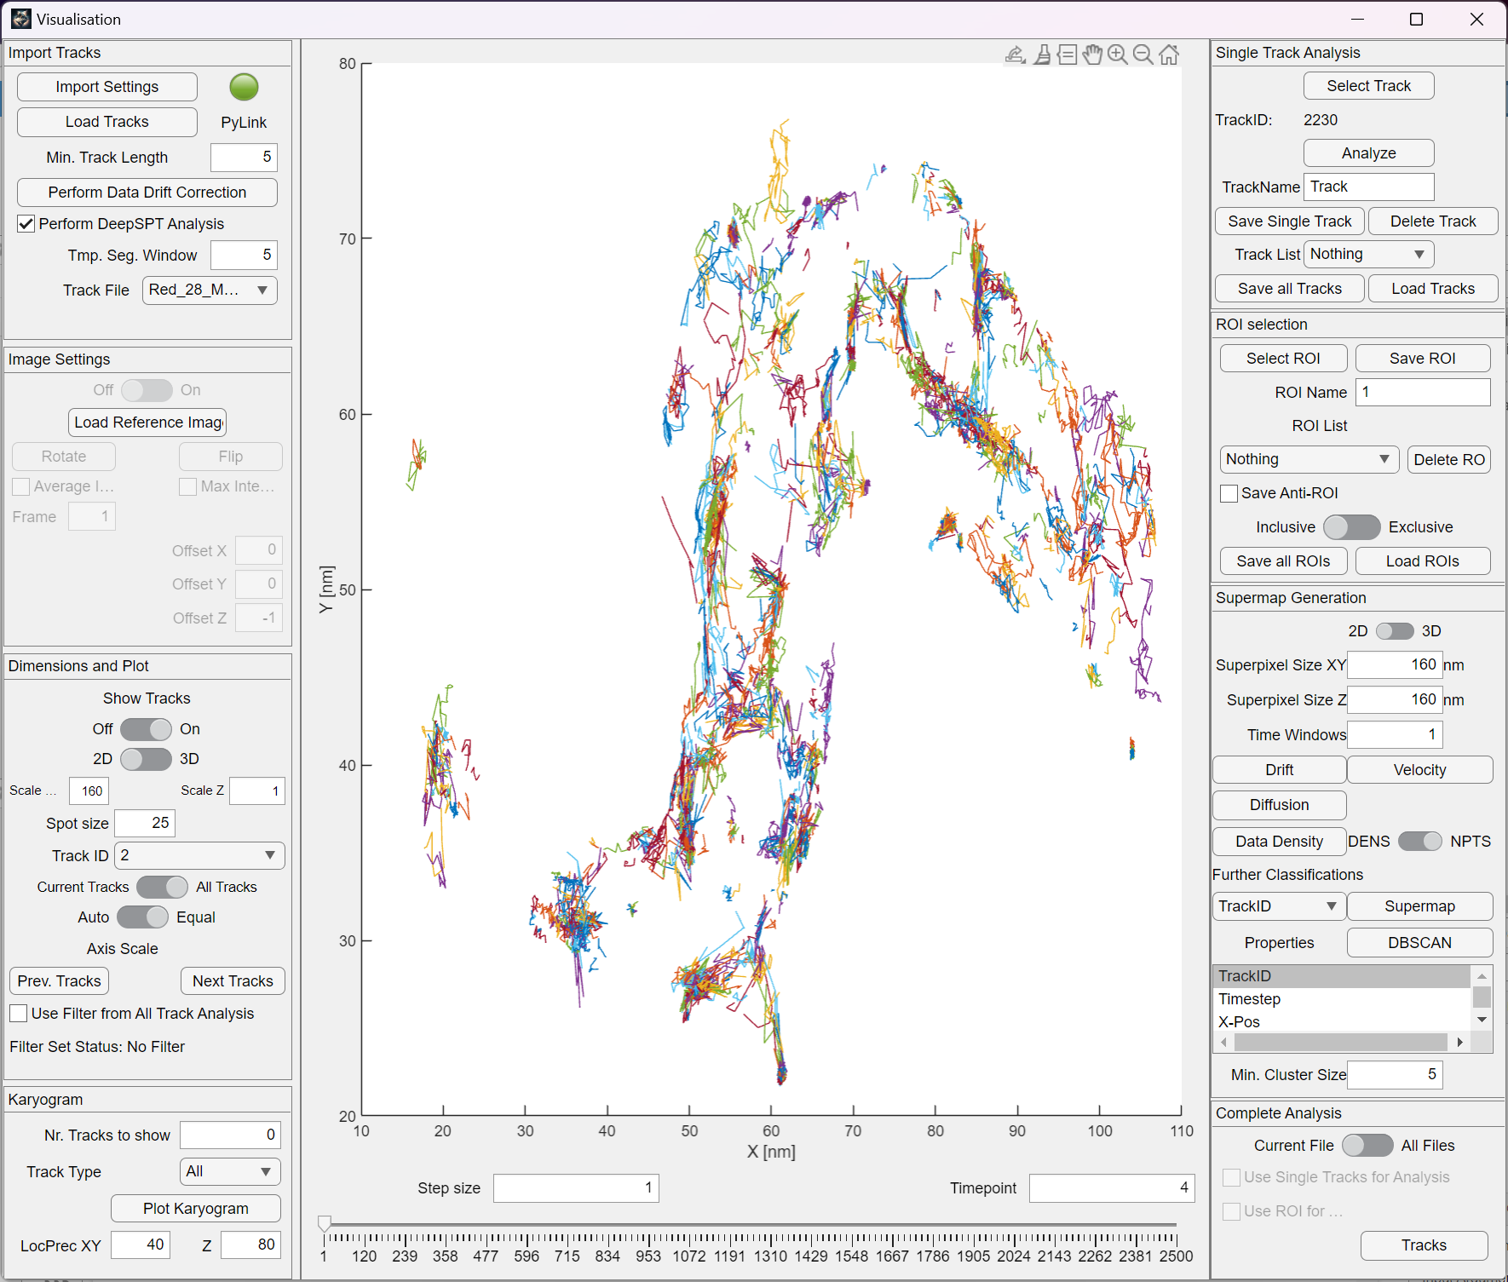

Figure 23: The supermap generation allows to bin data back into larger pixels, determining ensemble information within the data. The HDBSCAN allows to determine clusters of certain property combinations.

Especially when dealing with very short tracks, the option of aggregating data into larger super pixels can prove advantageous. This consolidation aids in delving deeper into the dynamics of the ensemble population. To execute this, the supermap generation panel can be utilized. As a starting point, a choice must be made between generating the supermap in either 2D or 3D.

The dimensions of the superpixels are determined by the values entered into the superpixel edit fields. Additionally, if an anticipation of distribution change over time exists, the "Time Window" parameter can be employed. This parameter divides the available data into distinct time windows, based on the value specified.

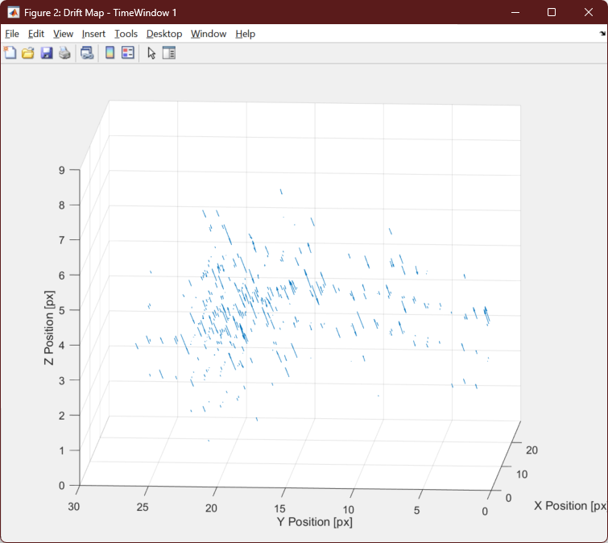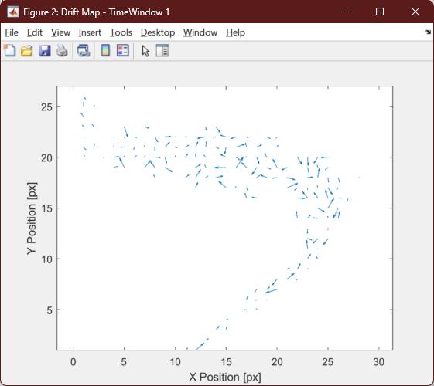With the press of the button, the process of creating the respective supermap is enabled.

Figure 24: Drift map in 2D and 3D of example data. Especially in 3D the sample drift becomes apparent.

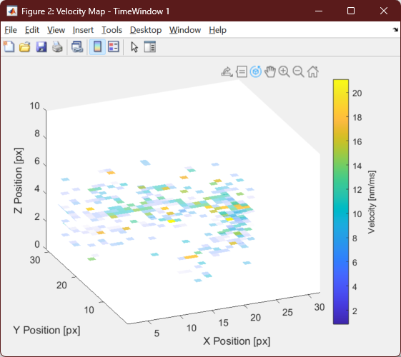The drift map provides a comprehensive representation of the prevailing movement direction within the specified dataset, applicable to both 2D and 3D contexts. Particularly in 3D, it becomes evident when the microscope's apparent sample drift becomes discernible. In the absence of effective drift correction, this microscope-induced drift can overshadow the intrinsic drift of the diffusion molecules, which is the focal point of our interest.

Figure 25: Velocity map in 2D and 3D of example data.

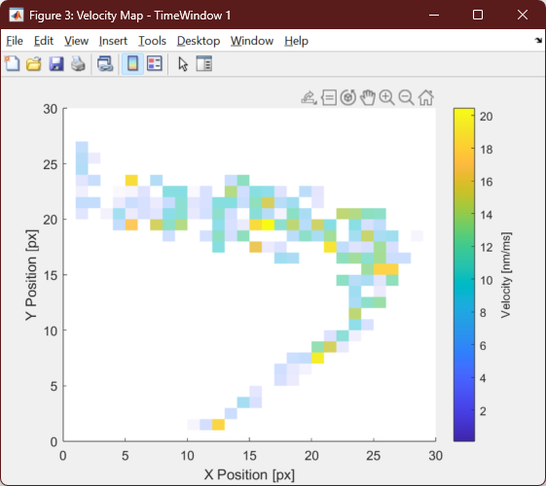

The velocity maps assist in pinpointing regions characterized by either rapid or gradual movement within our objects of interest. Through this, we can potentially infer certain functionalities or ascertain the need for adjustments in velocity, whether it involves an increase or decrease.

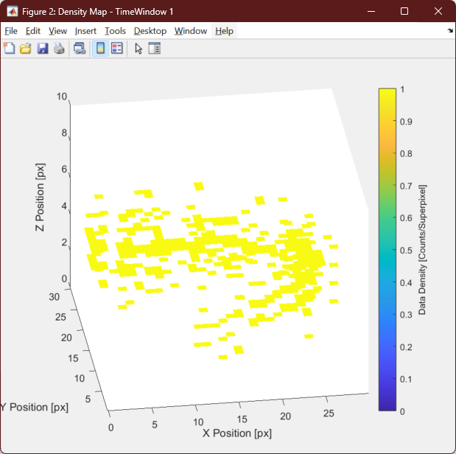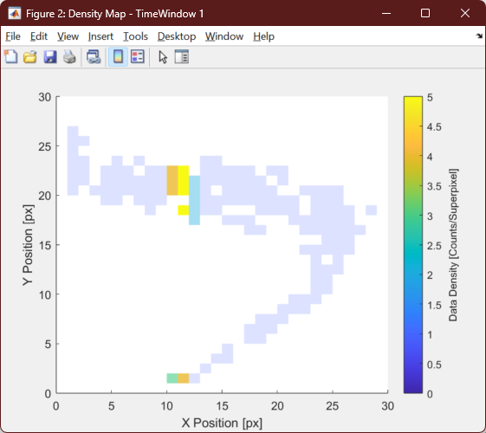

Figure 26: Density map in 2D and 3D of example data. It becomes apparent that the data in 3D is sparse.

The density maps provide us with insights into the reliability of the other supermaps. Given the limited number of data points, their influence on the outcomes of the Drift or Velocity maps could be significant, potentially leading to disparities. Consequently, the resulting maps may not accurately represent the collective behavior of multiple tracks within a specific region. Nevertheless, it does offer an indication of the primary localization areas within our individual images.

In the update version, we enabled the generation of supermaps with all calculated properties available to the software. The property can be selected from the dropdown menu. The pixel size and number of time windows can be controlled in the same way as for the other supermaps.

In addition, we also enable the automatic generation of clusters using the HDBSCAN algorithm with a free selection of properties.

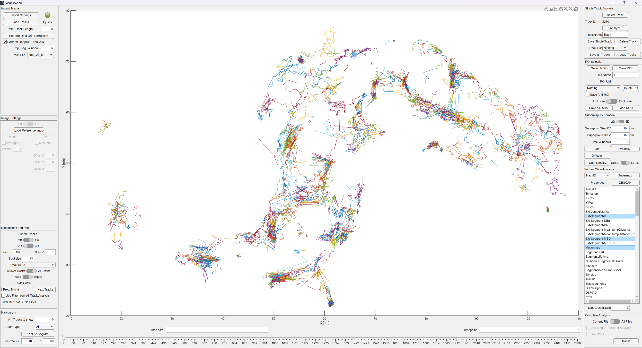Pressing the control key on windows allows to select multiple properties that will be used for the cluster generation. Temporal segmentation in time windows as well as the supermap generation is also possible with the clustered data. At the bottom of the property selection, a minimal cluster size can be selected to guide the algorithm to larger clusters.

### 2.4.9 Complete Analysis

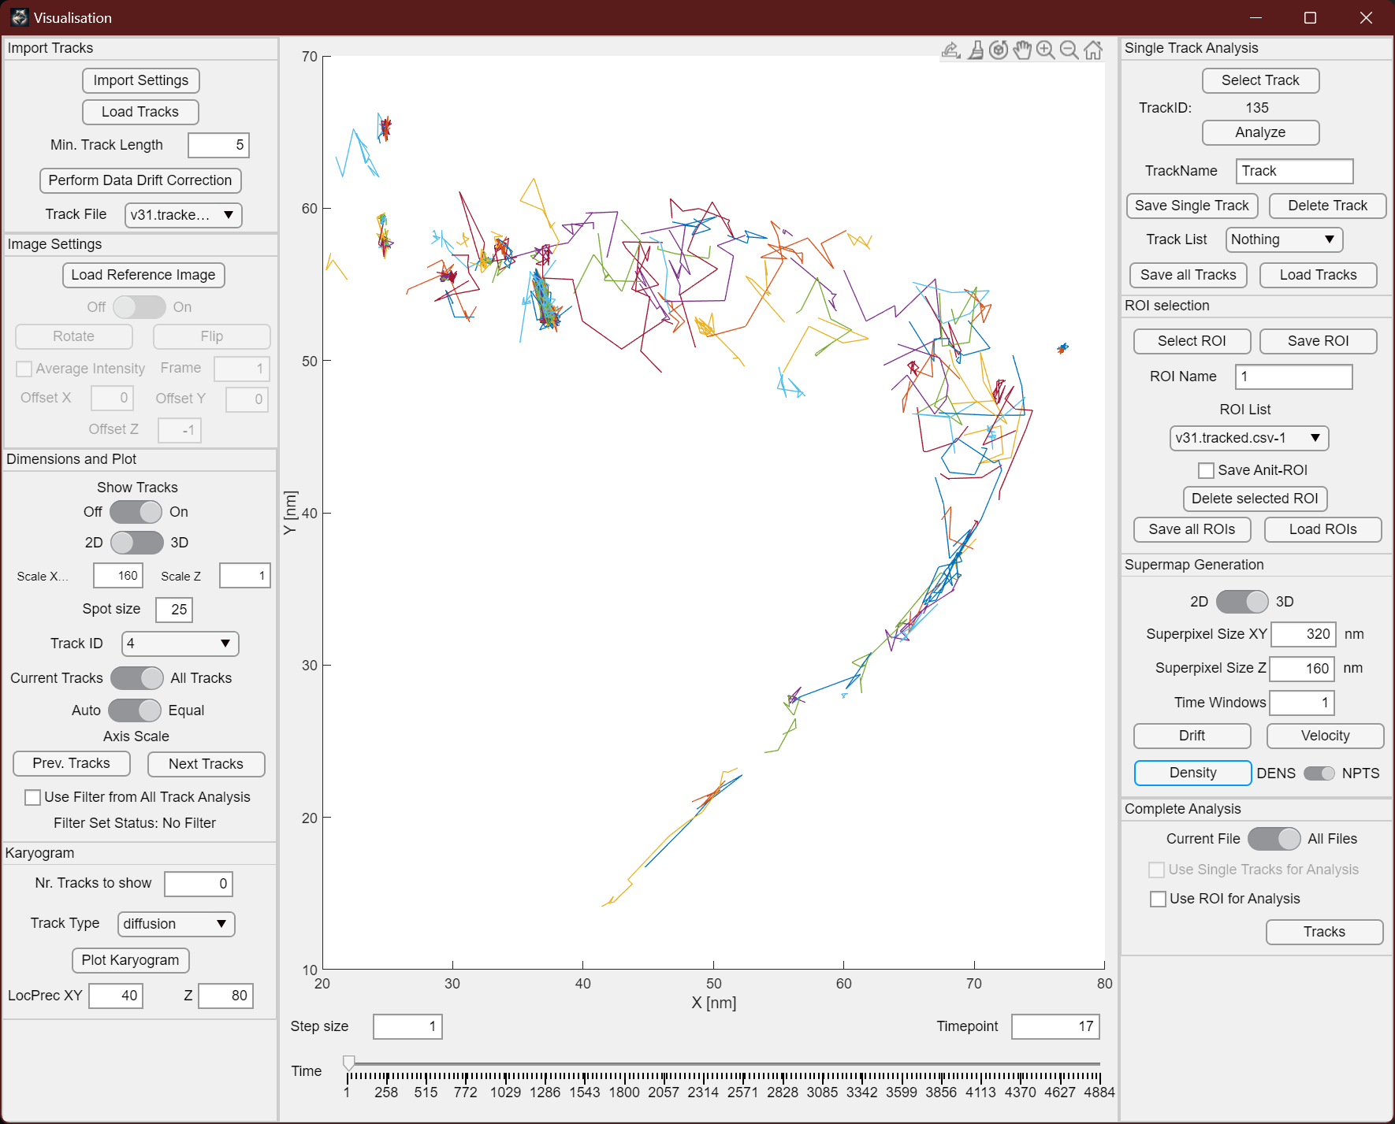

Figure 27: The complete analysis panel decides which data will be used for the complete anaysis in the analysis window.

The Complete Analysis panel determines the data that will be forwarded to the analysis window for further examination of the track data. Users have the option to select either the currently open file in the main window or all the loaded files within the software. Additionally, if individual tracks or regions of interest have been chosen, their corresponding checkboxes become accessible, allowing one option to be selected.

After making the appropriate selections, the user needs to click the "Tracks" button to initiate the data analysis process.

### 2.5 All Track Analysis

### 2.5.1 Overview

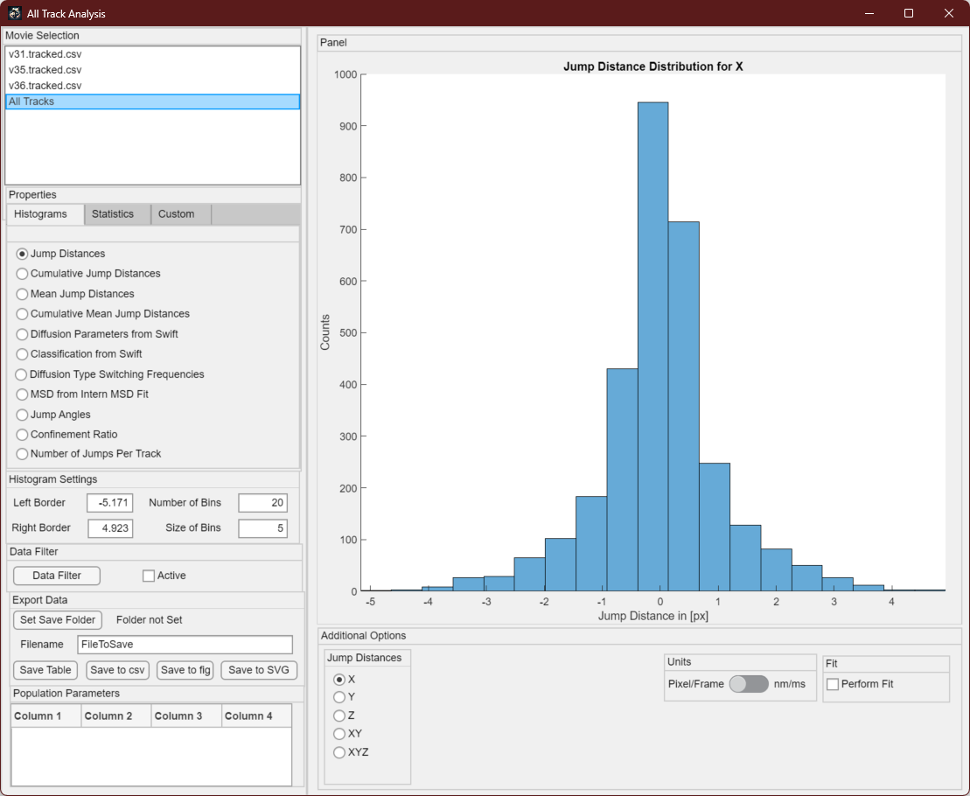

Figure 28: All Track Analysis Window after starting it. It will allow to adjust properties on the left as well as on the bottom of the window. The data will be shown on the right in a figure.

The all track analysis window serves as the platform for conducting in-depth assessments of individual particle tracks. Initially, users can opt to focus exclusively on data from a single file or encompass all the available data as a comprehensive dataset, comprised of all tracks. Within the properties panel, users have the flexibility to select among histogram displays, statistical analyses, and custom evaluations.

The histograms give a visual representation of data from the single particle tracks, enabling the examination of various properties through different histogram views. The histogram settings panel empowers users to customize the histogram's appearance. Parameters such as the left and right borders, the number of bins, and bin sizes can be adjusted. Beneath this, the "Data Filter" button is available, which opens the data filter window to further subset the data. More to this in the next chapter.

In the Export Data panel, users can specify a location for storing exported files. A designated file name can be assigned, and the content can be derived either from the table beneath the export field or from the figure itself. Export formats encompass CSV, fig, or SVG files.

The table situated in the lower-left corner displays data generated during the fitting process, encompassing diverse aspects that can be examined within this analysis window. Meanwhile, the Additional Options panel introduces supplementary choices, contingent on whether the Histogram or Statistics tab has been selected. This panel allows for transitions between dimensions, such as 2D or 3D, and facilitates switches between units of pixel frame and the true data units. Moreover, the fitting process's activation or deactivation can be toggled within this context.

### 2.5.2 Histograms

Jump Distances: Jump distances can be graphed for both X, Y and Z as well as in both 2D and 3D. Each jump distance is calculated as the Euclidean distance between the positions of two consecutive, connected spots in consecutive frames.

Cumulative Jump Distances: Cumulative jump distances signify the accumulation of each jump distance within each track, across the respective dimension.

Mean Jump Distances: The mean jump distance feature is the mean jump distance for a specific dimension within a given track.

Cumulative Mean Jumped Distances: This cumulative representation aggregates the mean jump distances for all tracks over time.

Diffusion Parameters from Swift: This aspect generates a plot of either the mean squared displacement or the diffusion coefficient, externally computed by the Swift algorithm or other employed tracking algorithms.

Classification from Swift: As the tracking algorithm categorizes single particle tracks into distinct types such as mobile, diffusive, or directed, these classifications can be depicted in a histogram.

Diffusion Type Switching Frequencies: The histogram here showcases the number of diffusion type switches per track as determined by the Swift algorithm.

MSD from Internal Data MSD Fit: The software itself calculates the mean squared displacement, wherein the user specifies the number of points for the fitting process (typically 10% of the average track length, but best also at least five steps). The choice between 2D and 3D fitting is presented before initiating the computation.

Jump Angles: Visualized in a polar histogram, jump angles provide insight into the track's motion type. Even distribution suggests Brownian motion, concentration around 180 degrees indicates confined diffusion or a bound state and centered around 0 degrees implies predominantly small directional changes and directed motion.

Confinement Ratio: The confinement ratio is defined as the absolute length divided by the net length of the track. The absolute length sums all step sizes, while net length considers only the distance between the first and last points. The ratio can also be used to determine a confined or diffusive behaviour.

Number of Jumps per Track: This histogram depicts the distribution of average track lengths within the dataset.

### 2.5.3 Statistics

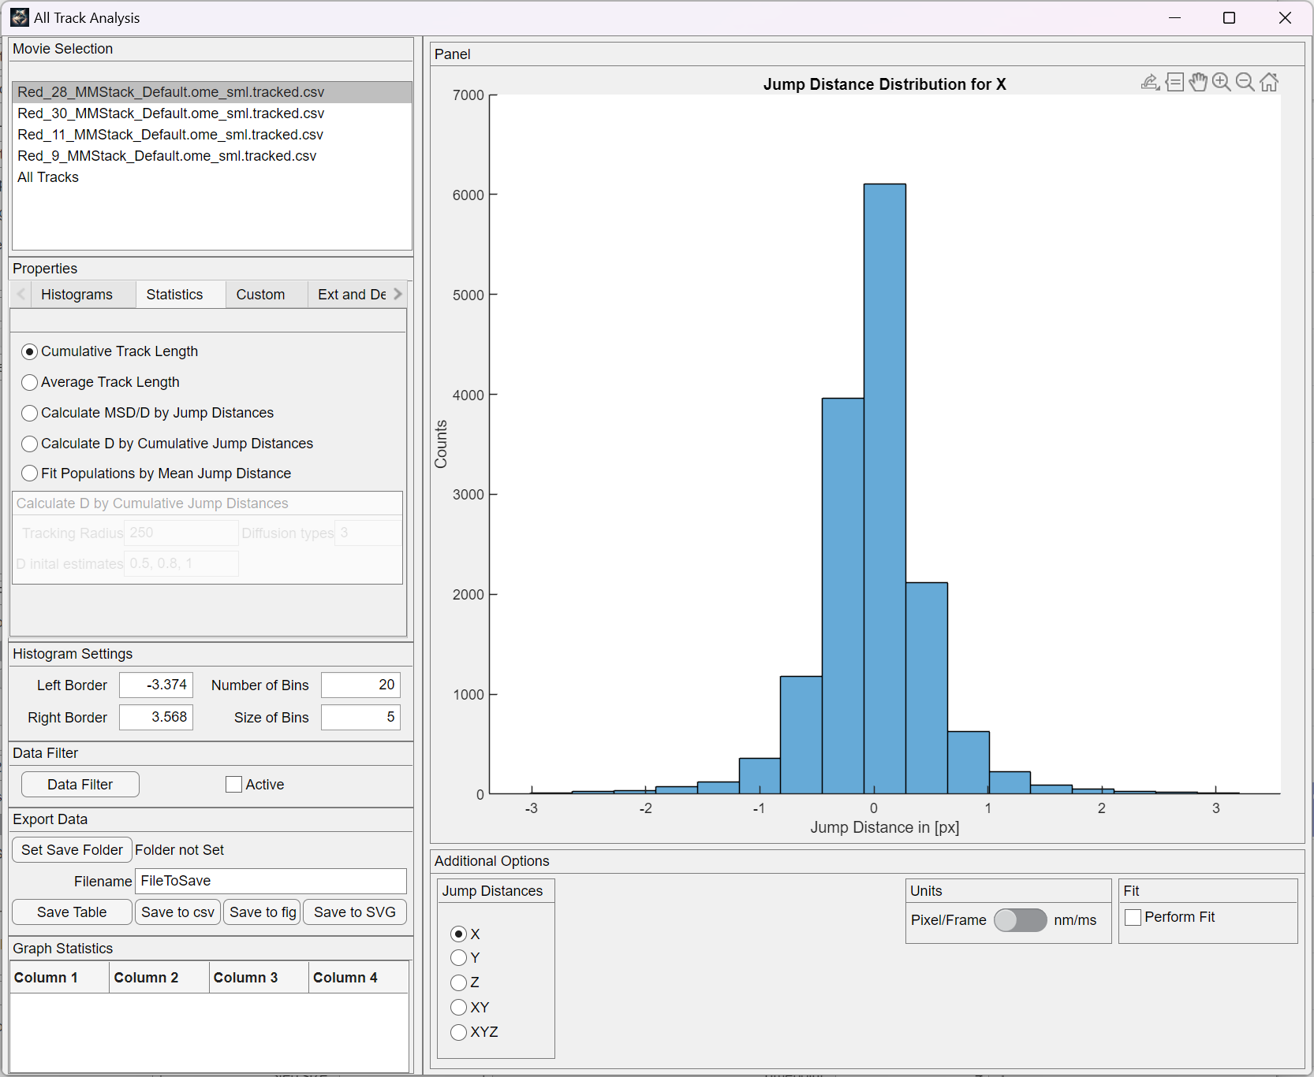

Figure 29: Overview of the function in the statistics tab of the software.

Accumulated Track Length: This plot displays the collective step sizes of the tracks, which can assist in identifying tracks that are notably lengthy or short.

Average Track Length: The mean track length is depicted here as a bar chart, encompassing the count of steps, total track length, and the average metal track length.

MSD Calculation via Jump Distances: The distribution of jump distances can serve as a basis for computing the mean squared displacement of the particles. To achieve this, a normal distribution is fitted to the one-dimensional jump distance distribution. Subsequently, the mean square displacement is determined using the standard deviation of the normal distribution. From this, the diffusion coefficient can be derived.

Alternative Approach for Diffusion Coefficient Calculation: Another method involves fitting a rate model onto the cumulative distribution of jump distances. This requires defining tracking radius and initial estimates for diffusion coefficients. The success of the fit is greatly influenced by the number of data points utilized in the fitting process. Convergence can be assessed through the R-squared value in the table and the error associated with the determined diffusion coefficient.

An Additional Technique for Determining Diffusion Coefficient: An alternative strategy entails fitting a mixed distribution model to the mean jump distance distribution. By identifying distributions around the primary jump distance, users may uncover distinct populations within their data that exhibit different movement speeds. Similar to previous methods, the quality of this fit hinges on factors like the number of data bins and the initial number of populations to be identified within the distribution.

#### 2.5.4 Custom functions

Confinement vs. Mean Jump Distance: In this context, the diffusion coefficients and characteristics of the immobile tracks are used to determine their confinement radius. Additionally, the mean jump distance is depicted against their corresponding confinement radius. This approach may unveil distinct populations of confined tracks exhibiting limited movement but distinct motion behaviors.

Tracks' Occupied Volume: This feature facilitates the computation of the area or volume, depending on whether it's in 2D or 3D, encompassed by the tracks. Two methods are at hand: one involves the convex hull, which tends to yield a relatively expansive area, and the other being the alpha shape. The latter considers track gaps more effectively, potentially leading to a result that better approximates the true area/ volume.

#### 2.5.5 External and DeepSPT

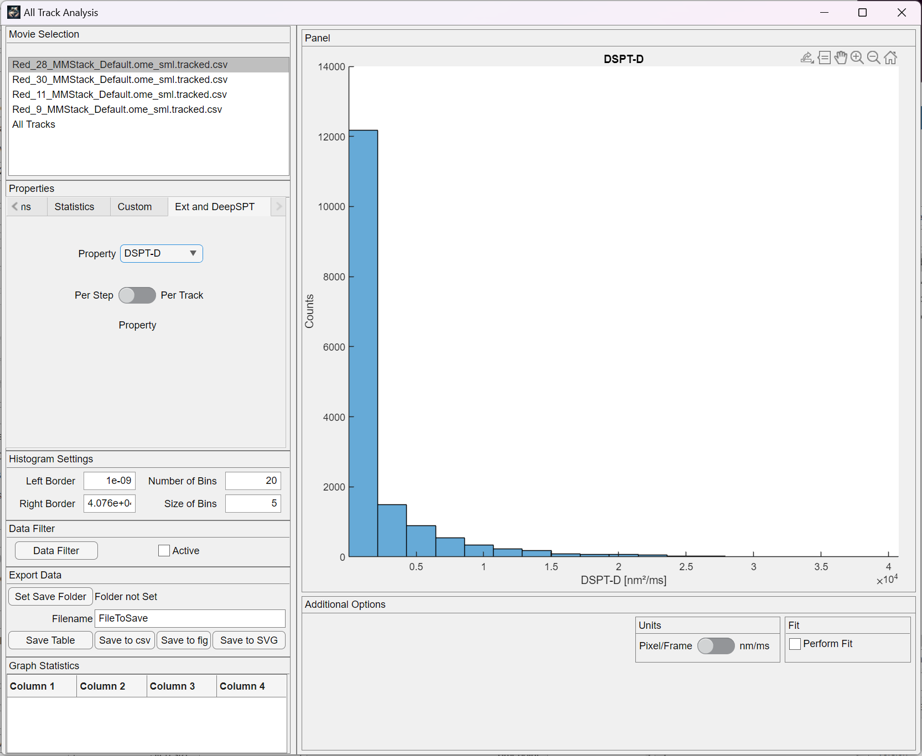

Figure 30: External data form DeepSPT.

In this tab, data generated from DeepSPT can be visualized. The user can choose if he either wants the data to be shown per step of all available tracks, or averaged per track over all the tracks. This might help to reduce the noise in the data visualization.

#### 2.5.6 Jump distance distribution (JDD) analysis

Implementation of the JDD analysis published by Menssen. This is an alternative method to determine the diffusion coefficients and eventually identify mixed populations of diffusive particles within the data.

Bootstrap iterations: This value determines how often bootstrapping will be performed to determine the error for the determination of the diffusion coefficients.

The drop down menue allows to select for different methods of binning used in the histogram. The users are free to explore different binning methods, as the results could be influenced by it.

The 3D data with 2D Diffusion analysis checkbox allows to determine the jump distances in 3D space, but use a 2D diffusion model to determine the diffusion coefficient. This could be useful for membrane diffusion.

The Sliding Window checkbox will segment tracks that are longer than the given window size into smaller fractions, thereby increasing the amount of data to be analyzed. Without a sliding window, each track that has the required window size will only considered once.

Window size: The time lag considered for the jump distance analysis. The user should explore different sizes of time windows to identify short-term and long-term effects of the diffusion behavior of the tracks.

The Do Model Fitting checkbox allows to also calculate the probability of the selected models to match the data. This effectively tells with which certainty a model is the correct one for the data.

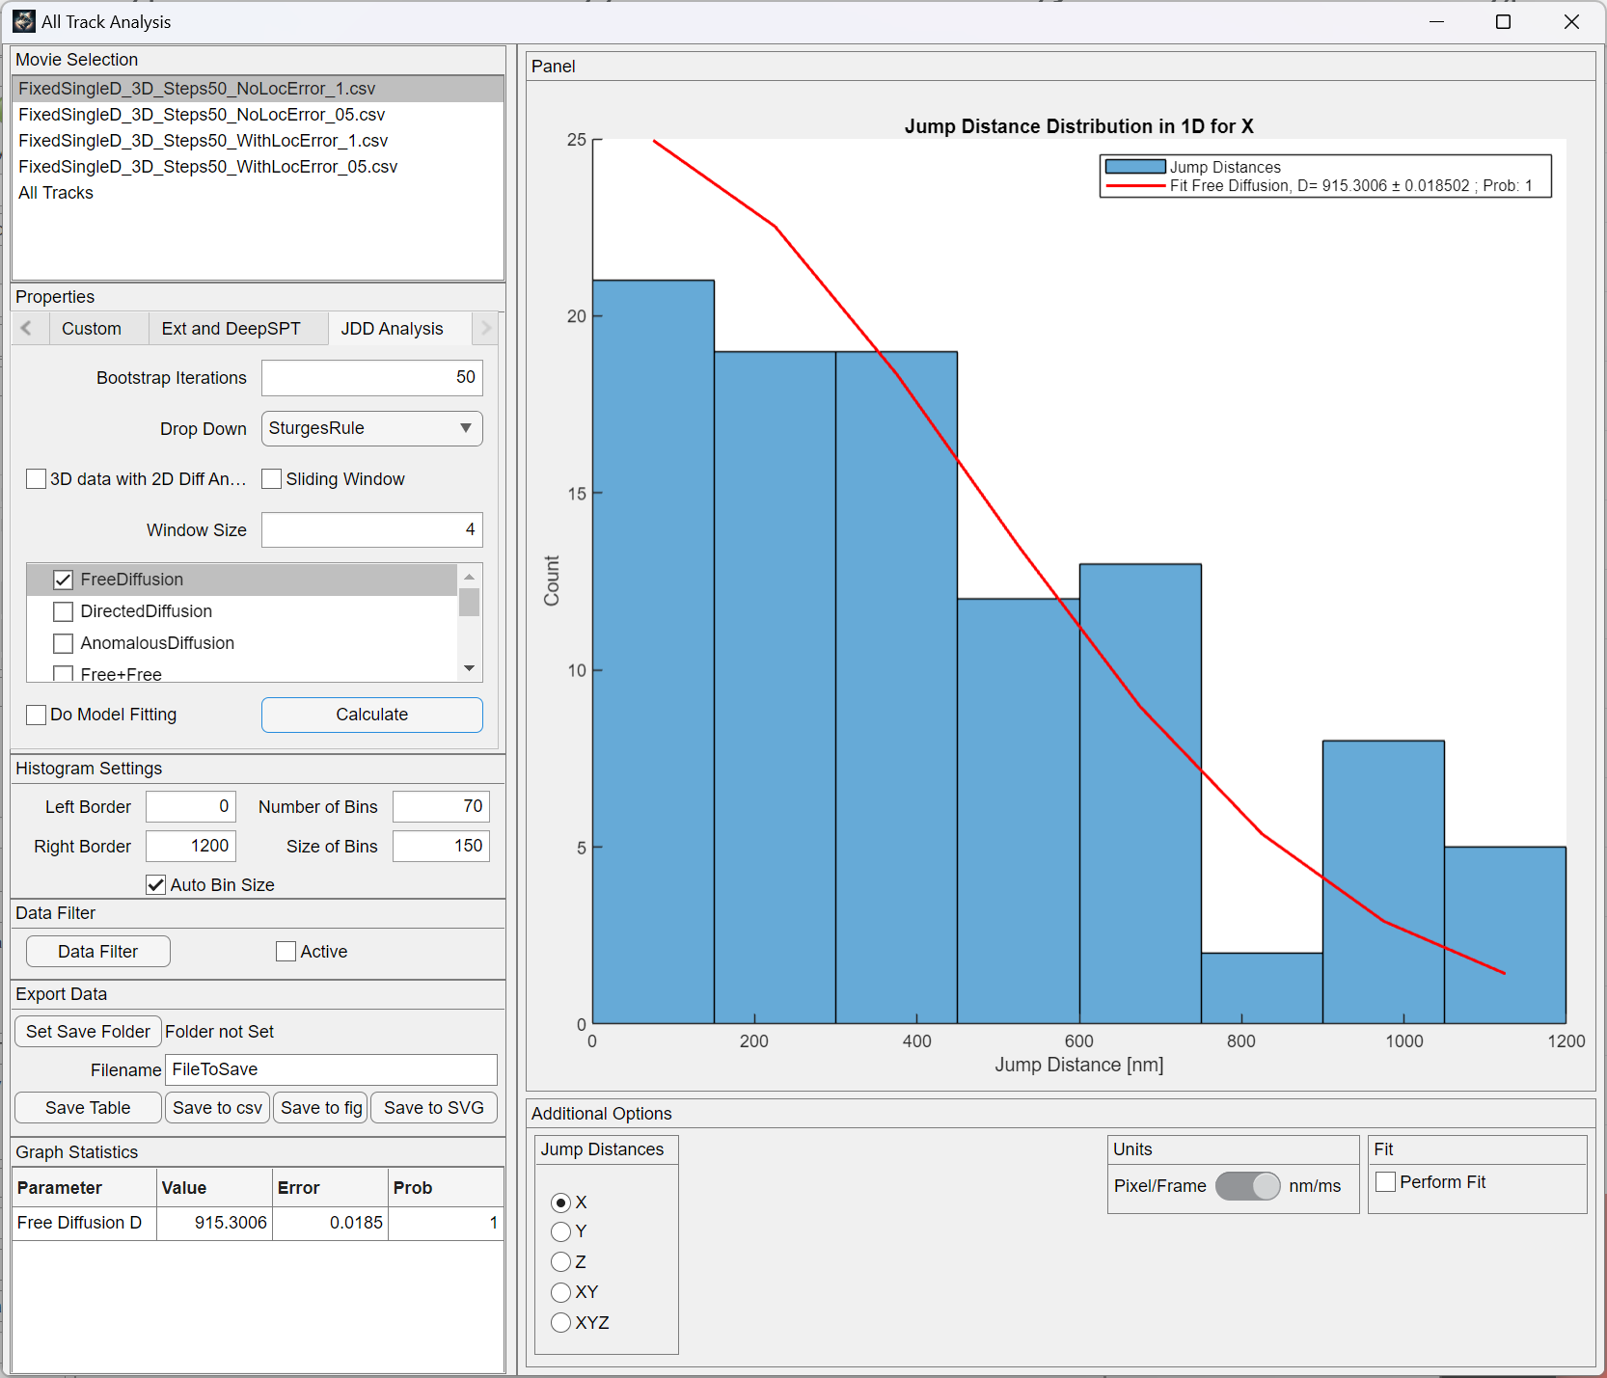

Figure 31: Interface for the JDD analysis.

All the calculated values will be displayed in the table in the bottom left corner of the GUI, from which it then can be saved suing the “Save Table” button or by simply copy and pasting the values.

### 2.5.6 Data Filter

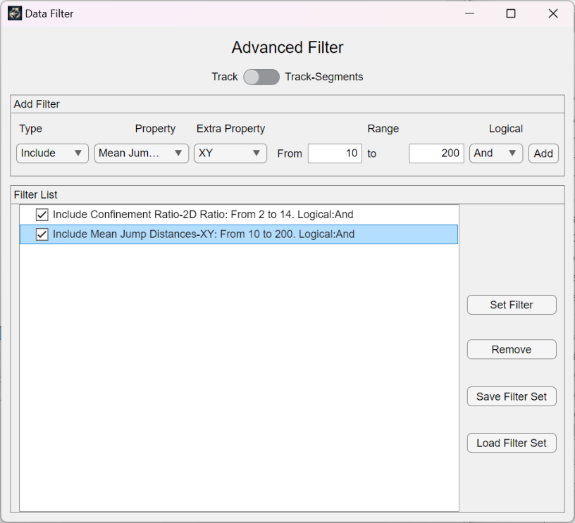

Figure 32: The data filter can be used to subset the data further by removing tracks that do not match the given properties.

The data filter serves to further refine the track data by selecting tracks that adhere to specific properties. Additional conditions can be incorporated by utilizing the "Add Filter" panel. For instance, if a particular property is to be included or excluded initially, this can be specified. Subsequently, the property itself can be selected, often depicted in the histograms within the all track analysis. In some instances, an extra property such as dimension or diffusion type may also need to be chosen.

At the top of the filter window, the user can choose to filter the whole track, or just track segments if they are available for the analysis.

A range can be defined to determine the scope of included or excluded tracks. Logical connections, either "AND" or "OR," can be employed to refine the filter criteria. With the respective button, the designated filter node can be appended to the filter list. Multiple filters can be combined, creating a concatenated set of conditions. Each filter must be manually activated by checking the corresponding checkbox to become effective.

Filters can be removed from the filter list using the "Remove" button. The entire filter list can be saved using the "Save Filter Set" button, and a saved filter set can be loaded using the "Load Filter Set" button. Once the desired filter arrangement is established, the user should activate the filters by pressing the "Set Filter" button. This action calculates the track IDs that meet the filter criteria.

In the all track analysis window, the user must manually activate the "Active" checkbox to apply the filter to the data. The user can easily toggle between filtered and unfiltered data by activating or deactivating this checkbox. The same filter settings are also extended to the visualization window, where they impact the depicted data.

### 2.5.7 Data Export

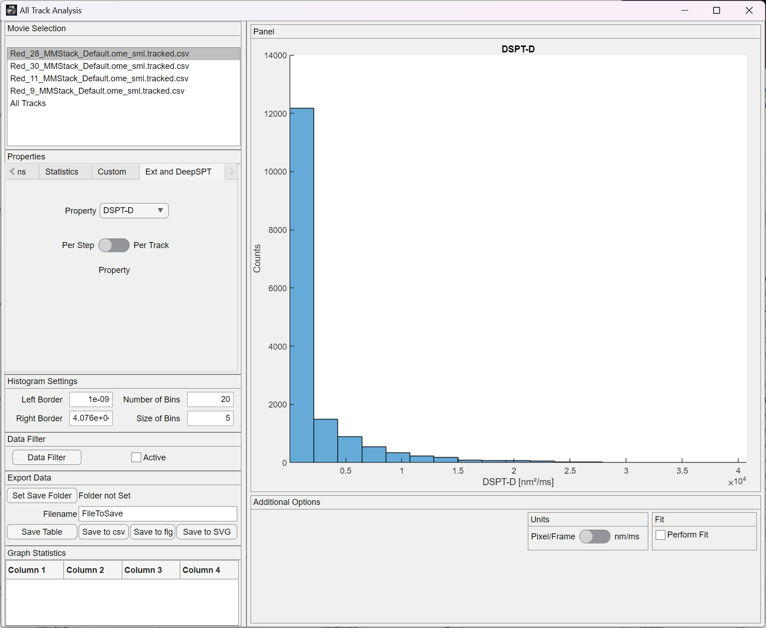

Figure 33: Export tab to save data and figures.

When visualizing data, the export tab enables the user to save the figure and the accompanying data in a folder of choice. After selecting the save location and entering a suitable filename, pressing one of the four buttons saves the respective data. Save table saves the data shown in the table below the tab. Save to csv saves the data that is represented in the histogram in the current figure on the right. Save to fig and save to svg saves the current figure to a matlab figure file or to a .svg file.